Document Purpose:
This document details how to set up Windows Active Directory Authentication on a Windows Server 2003 running SP1.
Note: Please keep in mind that case sensitivity is extremely important throughout the configuration.
Examples Used:
- BOService is the ID that was created in Active Directory. Feel free to create your own ID and pay attention to case.
- MYDOMAIN should be replaced with your Domain (Always use UPPERCASE when making these references in either your INI file or in your Business Objects environment.)
- MYDOMANCONTROLLER should be replaced with your Domain Controller Server’s name (Always use UPPERCASE when making these references in either your INI file or in your Business Objects environment.)

Instructions:
- Create a domain user account in your Active Directory. This ID will be used to run the Window Services and the CMS. (This example uses BOService)

- Now set the Service Principal Name using the following command. This command needs to be run on your Active Directory server at a command line prompt.
SETSPN –R BOService

- Once the SETSPN command had been run, Using the “Active Directory Users and Computer” windows utility on your Active Directory Server. Make sure the “Trust this user for delegation to any service (Kerberos only)” option is selected
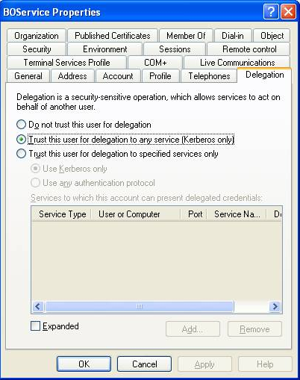
- Using the “Central Configuration Manager” windows utility, Verify that the CMS Service is using the BOService ID to run the service.

- Create a Krb5.INI file and place this file into the WINDOWS directory where Business Objects Enterprise is installed. See below. Pay attention to case, use UPPER case when defining your Domain and Domain Controller
[libdefaults]
default_realm = MYDOMAIN.COM
dns_lookup_kdc = true
dns_lookup_realm = true

[realms]
MYDOMAIN.COM = {
kdc = MYDOMAINCONTROLLER.MYDOMAIN.COM
default_domain = MYDOMAIN.COM
}

- Create a bscLogin.conf file and place this file into the WINDOWS directory where Business Objects Enterprise is installed. See below (note the line below appears on one line in the file).
com.businessobjects.security.jgss.initiate {com.sun.security.auth.module.Krb5LoginModule required;};

- On the Business Objects server, run the Tomcat Configuration windows tool. This can be found under the START MENU – Under TOMCAT. Add the following lines under the Java tab, in the Java Options list box (Please note the casing for the WINDOWS directory. If your server shows this as “Windows” then use “Windows” if it is “WINDOWS” then use “WINDOWS” etc etc. It is case sensitive.)
-Djava.security.auth.login.config=c:\WINDOWS\bscLogin.conf
-Djava.security.krb5.conf=c:\WINDOWS\krb5.ini
Screen Print of Tomcat Configuration Change
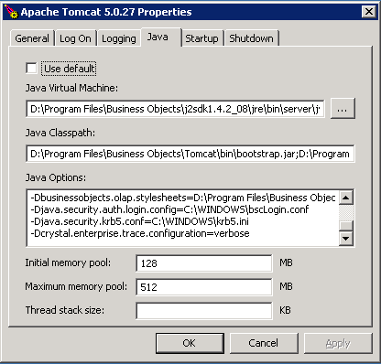
Note:
- If you experience authentication issues after your setup you can add the following line to the Java Options list box. This line will cause a log file to be created in \\Documents and Settings\”ntuser”\.businessobjects\jce_verbose.log
-Djava.enterprise.trace.configuration=verbose.
- Another debugging tool than can be used will be to look at the log file that was created by Tomcat. This can be found under \\Program Files\Business Objects\Tomcat\logs
- RESTART Tomcat after these changes.

- Start the CMC and login in as your Administrator.
- Navigate to the Authentication Management Area and select the Windows AD tab
- Check “Windows Active Directory Authentication is enabled”
- Set the “AD Administration Name:” to MYDOMAIN\BOService
- Set the “Default AD Domain:” to MYDOMAINCONTOLLER.DOMAIN.COM
- “Add AD Group” this will be any group that has access to Business Objects.
  - Example: MYDOMAIN\BOUsers
- Under Authentication Options select
  - “Use Kerberos Authentication”
  - Clear the check on “Cache Security Context (required for SSO to database)”
  - Set the “Service Principal Name:” to BOService
- Press the UPDATE command button.
- If users have been associated with your AD Group, they should now appear in the Users Management Area of the CMC.
  - Note: When a user is logging into INFOVIEW, they must use the same case as they were setup in Active Directory.
    - Hint: If the user was added to the Users Management area when you clicked the UPDATE command button on the Windows AD tab, the user should have been added with the same syntax as they appear in Active Directory.

- Now you should be able to open Infoview and test your changes.

Final Observations
- INFOVIEW is case sensitive and requires the user to use the same casing as they were setup in Active Directory.
- When running Desktop Intelligence, case sensitivity is NOT an issue.
- This example does NOT include using Single Sign On. We haven’t tackled that beast yet!



