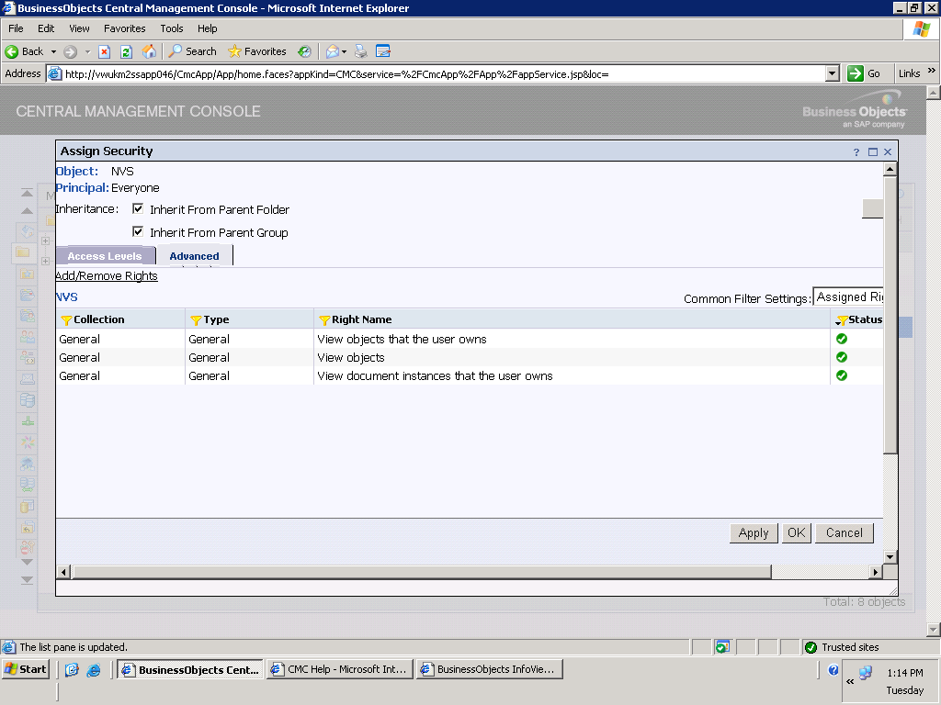

I can see now only Showing View not showing Modify(Really great) but when I view the report the below error is showing.
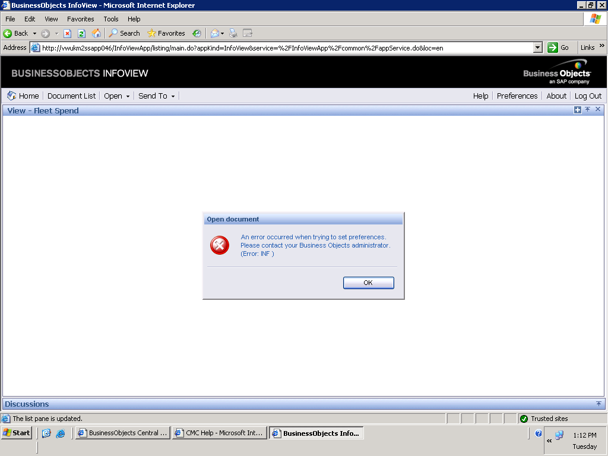

I am not able to give permission to all folder:

