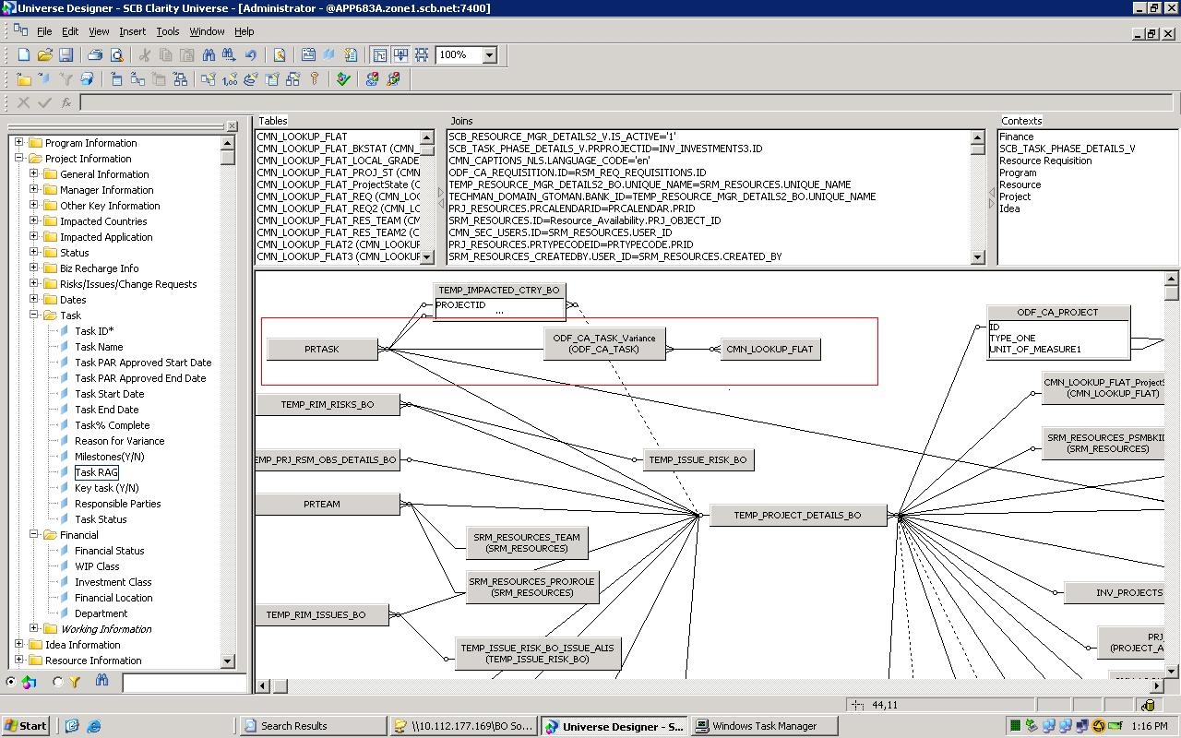
We are taking all the objects from Task class which are coming from 3 tables

