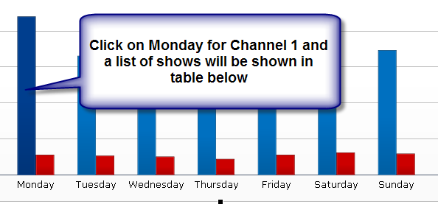

Top 5 Shows:
Show 1
Show 2
Show 3
Show 4
Show 5

