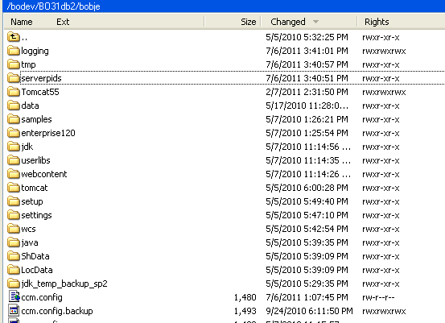
Old Tomcat

New Tomcat

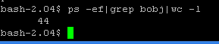
Total Number of BO Services running on Server
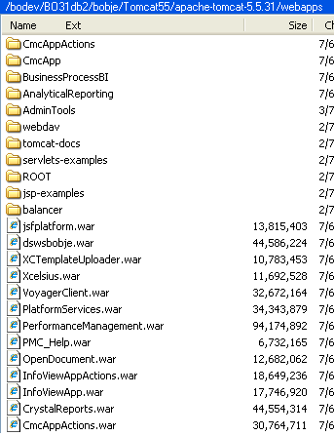
WAR files copied to the New Tomcat webapps Folder

