See below 2 screenshots
Screenshot 1: Error
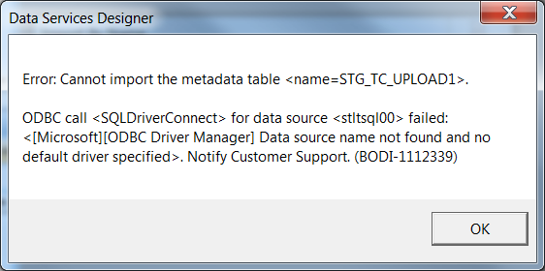

Screenshot 2: Datastore setup
