Please find the users_filedownload group with geoklan1 as user:
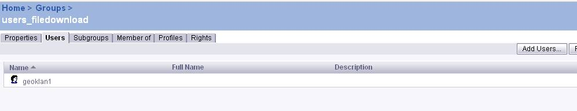

The group users_filedownload has rights to a secured connection 'New
connection'

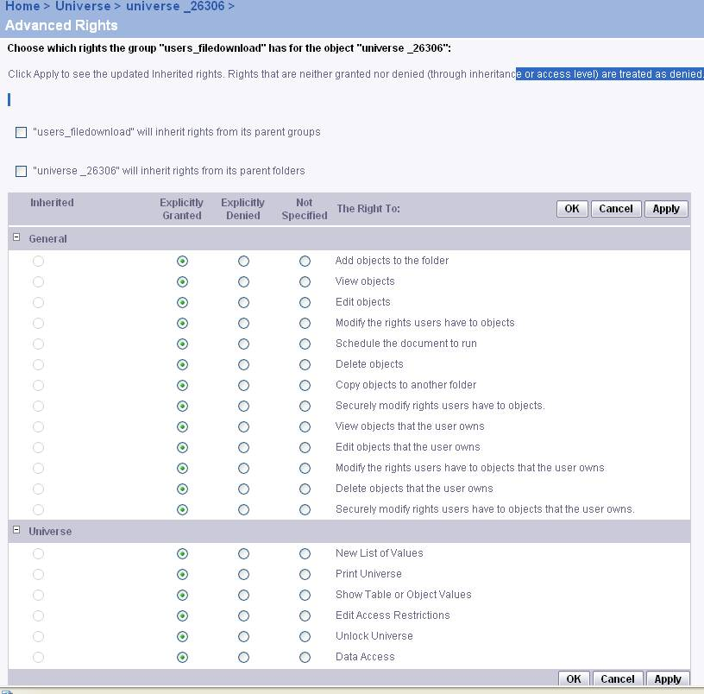

The following shows rights of group 'users_filedownload' to the universe
'universe 26306':

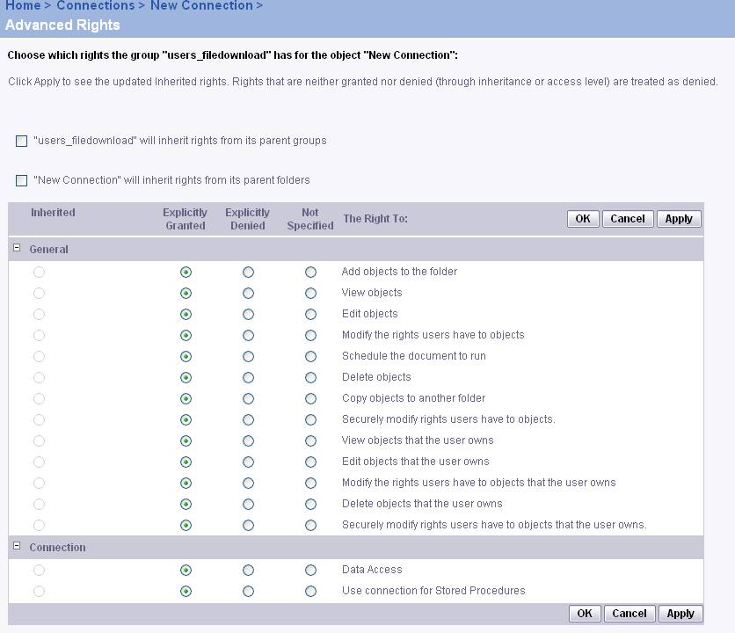

And the rights of group users_filedownload to Desktop intelligence:

