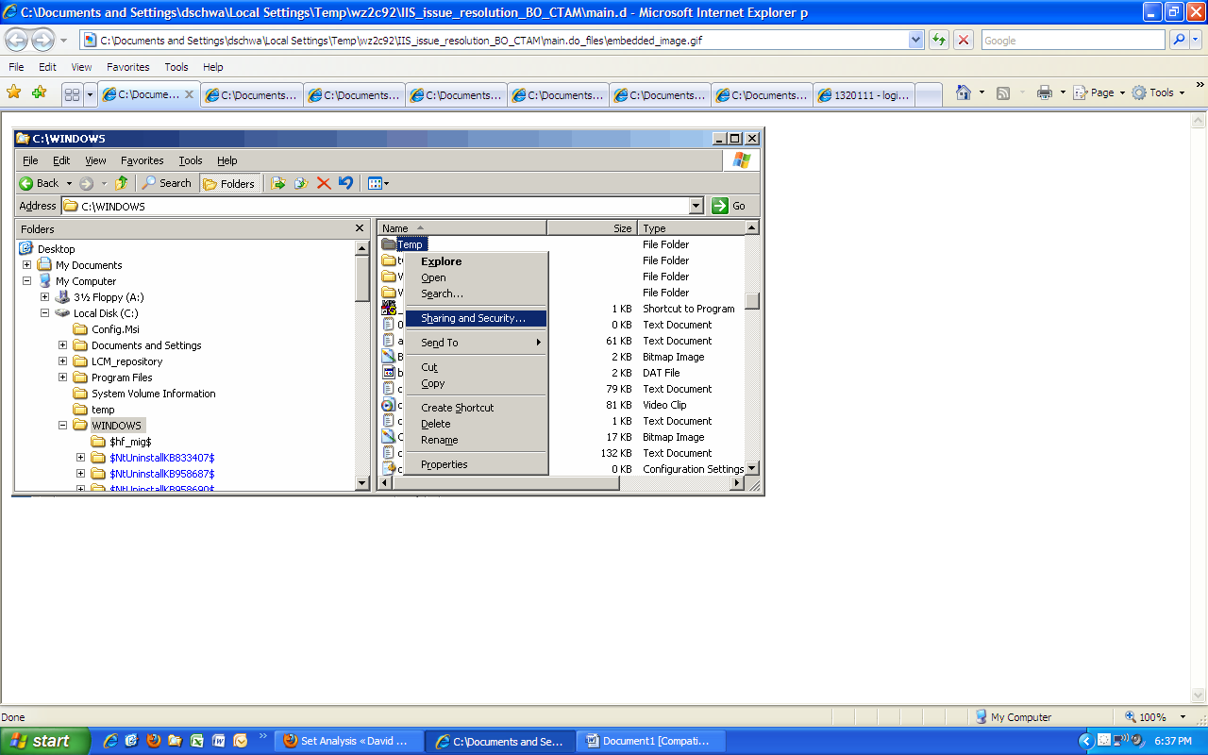

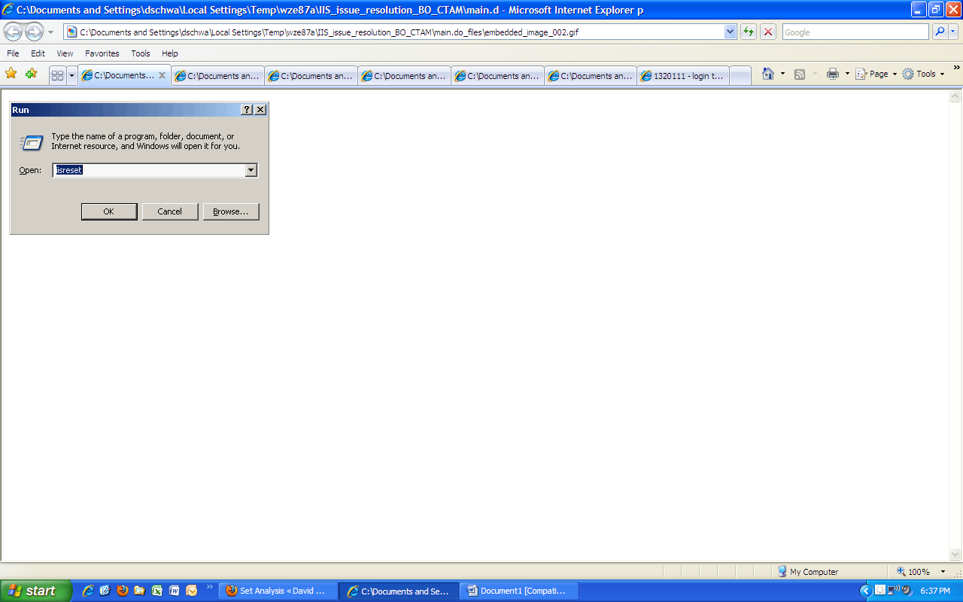

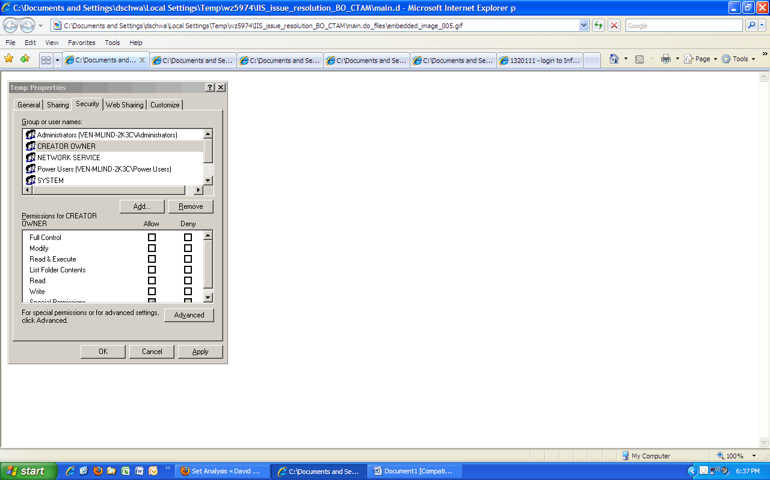
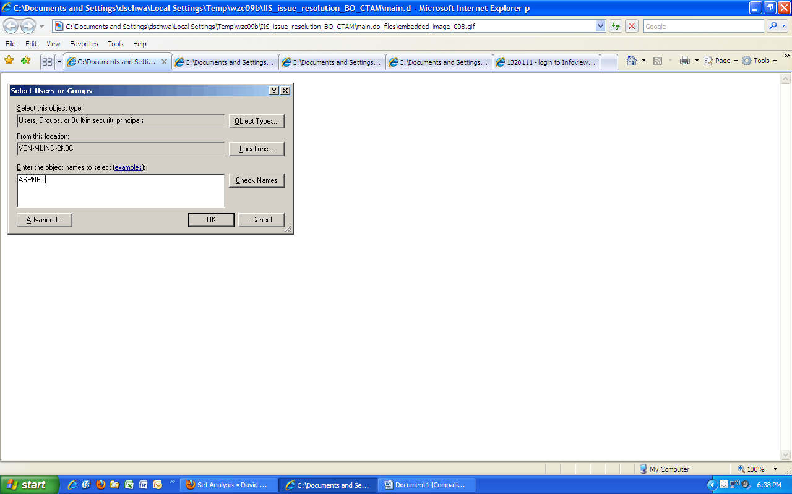

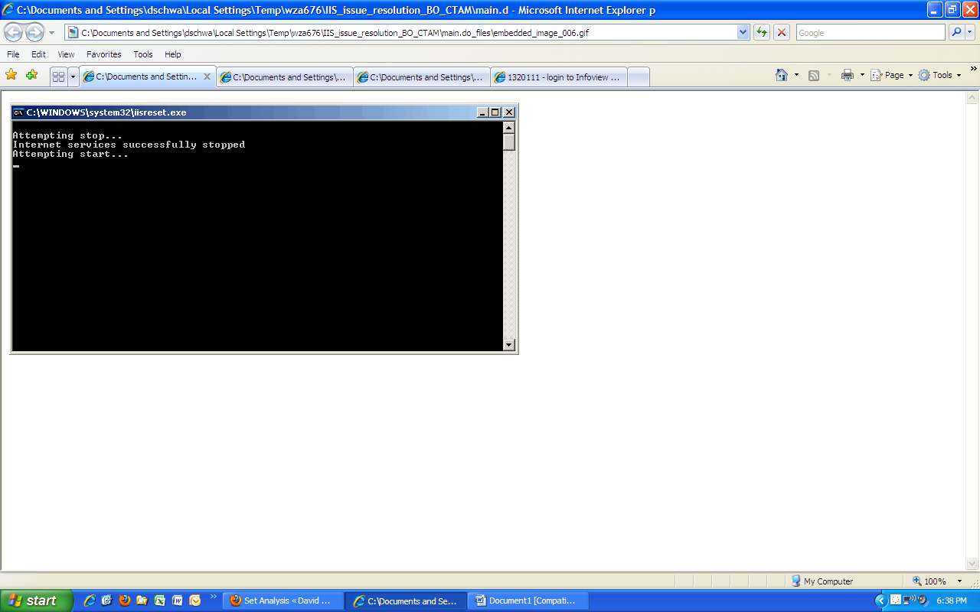

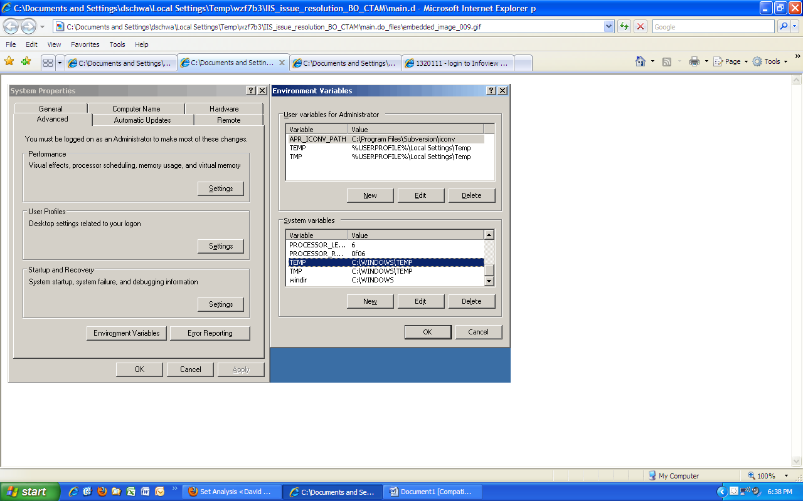
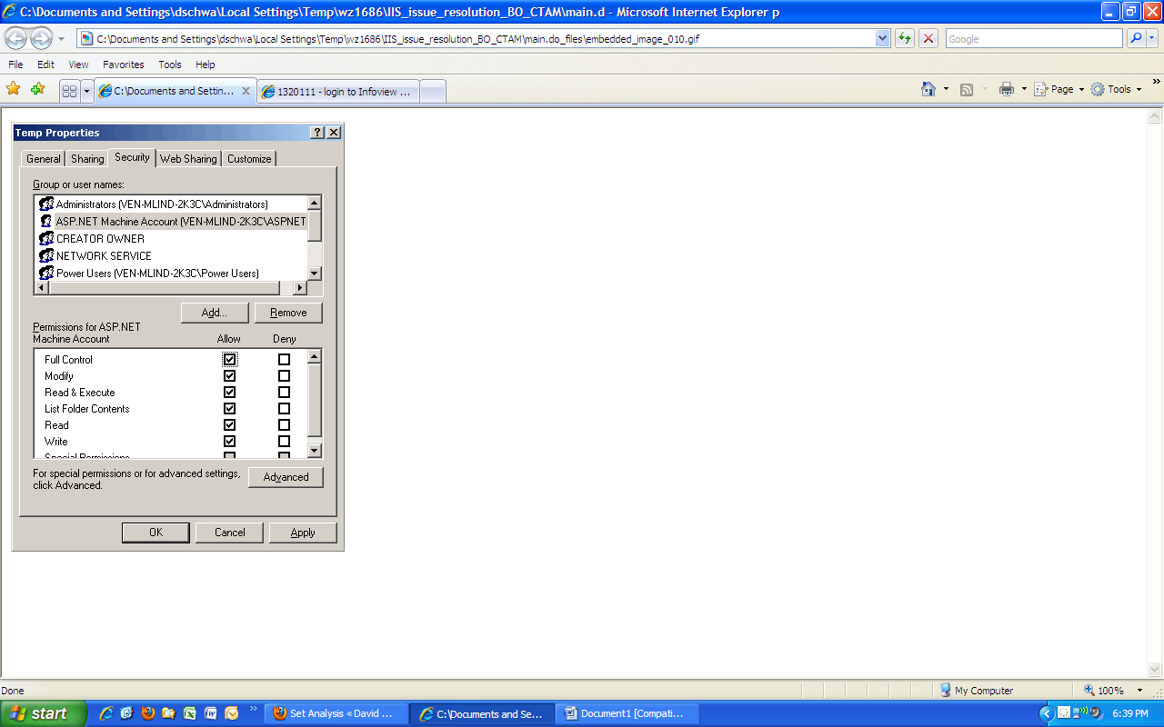

SAP Knowledge Base Article
1320111 - login to Infoview or CMC gives "CS0016: Could not write to output file 'C:\Windows\Microsoft.NET\Framework\v2.0.50727\Temporary ASP .NET Files\application1\c11b43f6\d78f5246c\werygvasde.dll'
  Version 1 Validity: 19.03.2009 - active
  Language English

Symptom
Instead of displaying the logon screen of Infoview, IIS generates the error message "CS0016: Could not write to output file 'C:\Windows\Microsoft.NET\Framework\v2.0.50727\Temporary ASP .NET Files\application1\c11b43f6\d78f5246c\werygvasde.dll'. Permission denied.

Reproducing the Issue
- Open .NET Infoview.
Business Objects Enterprise XI R2

Cause
The IIS user doesn't have rights on the Windows temp directory
This happens with Business Objects Enterprise XI Release 2 after installing certain Windows security patches or changing permissions.

Resolution
1. Left-click on Start, then select "Control Panel":
2. Open "System", then left-click the "Advanced" tab. Left-click "Environment Variables". Note the path of the TEMP and TMP variables under "System variables":
3. Left-click the Start button, then click "Explore":
4. Navigate to the path of the TEMP and TMP system variables mentioned above, right-click on the folder and select "Sharing and Security":
5. In the Properties window coming up, left-click the "Add" button:
6. Type "ASPNET" in the "Object name" box and left-click "OK".
7. Tick the box in the same line as the "Full Control" caption in the "Allow" column by left-clicking on it. Left-click "Apply" to apply the change.
8. Left-click on Start, the select "Run":
9. Type "iisreset" in the "Run" window and press Return. This will restart the Internet Information Server.
10. Wait for the black window to disappear.

See Also
Refer to the Microsoft KB article 825791 (http://support.microsoft.com/kb/825791) for further details.

Header Data
Released on | 20.03.2009 12:13:16
Release status | Released to Customer
Component | BOJ-BIP-DEP Server installation, migration, LCM, architecture, 3rd party
Priority | Normal
Category | Problem

References
Type | ID | Title
The table does not contain any entries

Product
Product | Product Version
SAP BusinessObjects Enterprise | BOBJ ENTERPRISE XI R2

