SAP BODI Overview

Table of Contents
1. AGENDA 3
1.1. ETL & DATA MIGRATION 4
1.2. HISTORY AND OVERVIEW 5
1.3. ARCHITECTURE AND COMPONENTS 6
1.4. DESIGNER OVERIVIEW 10
1.5. BODI OBJECTS 14
1.6. BODI JOBS DEMO 19
1.7. DEVELOPER 101 22
1.8. ADVANCED CONCEPTS 36
1.9. TEAM BASED DEVELOPMENT 38
1.10. CODE MIGRATION 45
1.11. WEB ADMINISTRATION 45
1.12. BODI BEST PRACTICES 49

AGENDA
- ETL & DATA MIGRATION
- HISTORY AND OVERVIEW
- ARCHITECTURE AND COMPONENTS
- DESIGNER OVERVIEW
- BODI OBJECTS
- BODI JOBS DEMO
- DEVELOPER 101
- ADVANCED CONCEPTS
- TEAM BASED DEVELOPMENT
- CODE MIGRATION
- WEB ADMINISTRATION
- BODI BEST PRACTICES

ETL & DATA MIGRATION
(E)xtract→(T)ransform→(L)oad
- In computing, ETL refers to a process in database usage & especially in data warehousing that:
- Extracts data from homogeneous or heterogeneous data sources (Excel/Legacy Systems/Database)
- Transforms the data for storing it in proper format or structure for querying and analysis purpose
- Loads it into the final target (Database/SAP)
SAP Business Objects Data Integrator/ Services
- The presentation is designed to enable ETL developers on SAP Business Objects Data Services. It covers an audience of mixed experience levels and tries to provide information on key SAP BODI features.
- A certain amount of self-study and hands on experience would be required to be productive.
- Understanding of data warehousing and ETL concepts, exposure to some relational database would be prerequisites for this training. Experience with other ETL tool would help but is not necessary.
Why SAP Business Objects Data Services?
- There are many other software tools in the market which can do the same functions or activities as SAP BODI.
- These tools are the direct competitors for Business Objects Data Services i.e Cransoft, DSP Migrate, Informatica, Datastage, Cognos, and SSIS etc.
- The tool provides a very easy and efficient interface to perform these specialist tasks which involve data manipulation. The objects and functions within BODI are specifically designed to perform manipulations and transformation of huge and complex volume of data very efficiently.
- There are systems provided objects and functions which can be dragged and dropped easily and jobs can be created. Direct loading of data into SAP ECC system can also be done using BODI.

HISTORY AND OVERVIEW
- 2003 & earlier: Business Objects acquires a company called Acta which offer ETL Tool “Acta”. Re-launched as Data Integrator 6.5
- 2003-07: Data Integrator next releases 11.5 -7-7.2
- 2007 –Present: Business Objects acquires Firstlogic, Inxight and merges them into Data integration platform, re-launches as Data Services 3.0 (internal version 12.0). SAP acquires Business Objects, product renamed as SAP BO Data Services.
- Future: Expect more tighter integration with SAP (MDM & ERP), especially with better API’s to load data directly into SAP internal data structures.
BODI is a GUI Workspace that allows to create jobs that:
- Extracts data from heterogeneous sources.
- Transforms that data using built-in transforms and functions to meet business requirements
- Loads the data into a Target (Datastore\Data warehouse\SAP) for further analysis.
- SAP BODI/DS can be used for both real-time and batch jobs.
Pre-Requisites
- Hardware – PC with minimum 1 GB RAM and Processor 3i & above
- Software – SAP Data Services, IPS preinstalled. Any RDBMS preinstalled. The RDBMS would have to be installed prior to BODI.
- Programmer/Consultant/Resource – Basic programming knowledge and basic SQL knowledge. In other words anyone who understands the programming terms - “If then else “,”Loops”, Database, Tables, Query, DML and DDL statements. Also, someone who recognizes or is aware of business terms like Data, Transformation, “ETL”, “Data warehousing”, “Data Migration”, ERP (some these terms are explained briefly in the following chapters) and familiarity with names of popular databases and software and ERPs like SAP, Oracle, SQL Server.

ARCHITECTURE AND COMPONENTS
Business Object DS Architecture
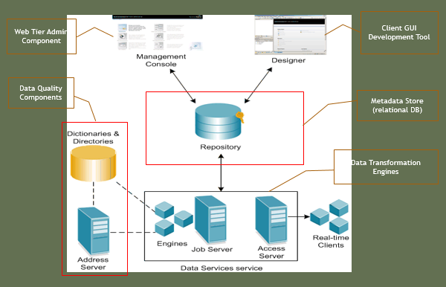
Business Object DS Distributed Architecture 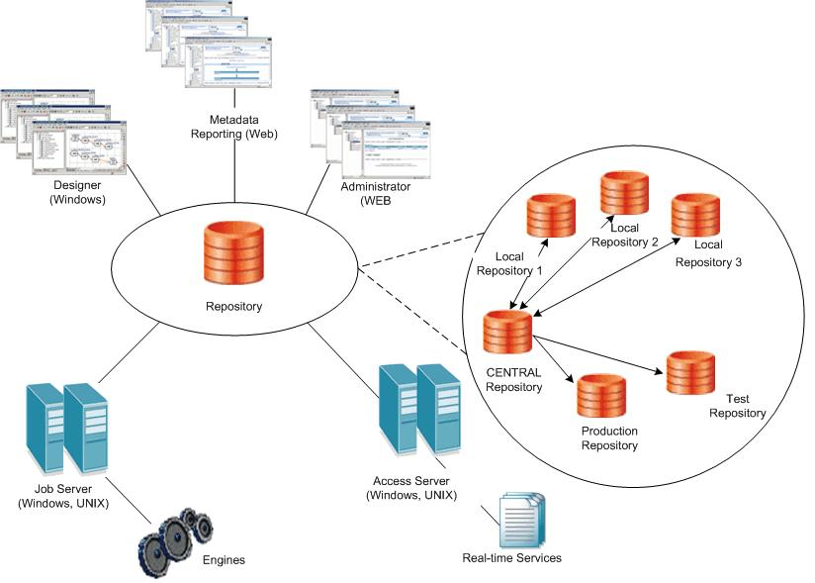
Business Objects DS Components
The BODI Components are classified into three categories:
- Standard BODI Components
- Optional BODI Components
- BODI Management Tools

Standard BODI Components
- Data Services Designer
- Data Services Repository
- Data Services Job Server
- Data Services Engine
- Data Services Access Server
- Data Services Administrator
- Data Services Metadata Reports Applications

Optional BODI Components
- Data Services Multi User
Designer
- It is a development tool with a unique GUI that allows you to create, test & execute jobs that populate a data warehouse.
- It enables developers to create objects; drag, drop & configure them by selecting icons in a source-to-target flow diagram.
- It allows you to define data mappings, transformations & control logic.
- It is used to create applications specifying work flows (job execution definitions) & data flows (data transformation definitions

Job Server & Engine
The Job Server is an application that launches the Data Services processing engine and serves as an interface to the engine and other components in the Data Services suite.
When DI Jobs are executed, corresponding Job Server gets the job from its associated repository, starts a DI Engine to process the job using parallel processing and in-memory data transformations.
Repository
- A set of tables that hold user-created & predefined system objects, source & target metadata & transformation rules.
- Allows sharing metadata with other enterprise tools.
- Uses an existing RDBMS.
- Associated with one or more Job Servers which run the jobs you create.

Types of Repositories in BODI
- Local: Developer Sandbox
- Central: Team collaboration, with access & version control
- Profiler: Create profiling jobs, stores statistics for profiler jobs.

Access Server
- The Access Server passes messages between web applications and the Data Services Job Server and Engines.
- It provides a reliable and scalable interface for request-response processing.
- It is a real-time, request-reply message broker that collects message requests, routes them to a real-time service, and delivers a message reply within a user-specified time frame.

BODI Management Tools
- License Manager: Client tool to manage licenses for DS and other licensed packages
- Repository Manager: Client tool to create, upgrade repositories
- Server Manager: Server component to create/administer Job Servers, adapters, manage repository associations
- Metadata Integrator: Component to share repository metadata with Business Objects Intelligence products.

DESIGNER OVERIVIEW
Designer Overview
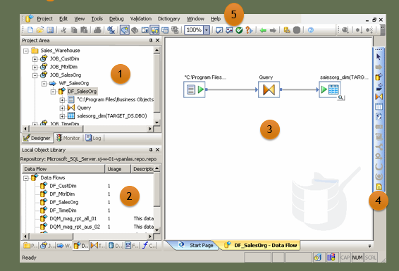
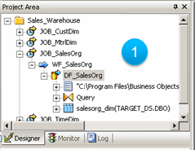
Project Area
- The project area provides a hierarchical view of the objects used in each project. Tabs on the bottom of the project area support different tasks.
- The Project Area contains three tabs
  - Designer
  - Monitor
  - Logs

Local Object Library
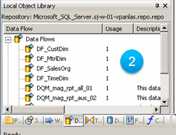
- The local object library provides access to reusable objects. These objects include built-in system objects, such as transforms, and the objects you build and save, such as data stores, jobs, data flows, and work flows.
- The Local Object library contains eight tabs
  - Projects
  - Jobs
  - Work Flows
  - Data Flows
  - Transforms
  - Data Stores
  - Formats
  - Custom Functions

Workspace
- The workspace area provides a space to build the ETL Job flow using a combination of workflows, data flows, scripts and transformations, etc. Tabs on the bottom of the workspace can relate to multiple workspaces which can be accessed at any time.
- The Workspace Area can contain
one or more tabs
  - Start Page
  - Workspace(s)
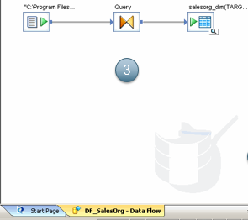
New Addition Toolbar
- The new addition toolbar provides options to create new data flows, workflows, tables, scripts, etc. to be used while building the ETL Job flow.
- The New Addition Area contains variety of new objects to the ETL job flow
  - Dataflow
  - Workflow
  - Query
  - Template Table
  - Conditional Workflows
  - Loops
  - Try Catch Block
  - Scripts

Menu Bar & Tool Bar
- The Designer user Interface also contains Menu Bar and Tool Bar.
- The Menu Bar contains the following Menus
  - Project Menu
  - Edit Menu
  - View Menu
  - Tools Menu
  - Debug Menu
  - Validation Menu
  - Window Menu
  - Help Menu


BODI OBJECTS

BODI Objects
- All "entities" you define, edit, or work within Designer are called objects. The local object library shows objects such as source and target metadata, system functions, projects, and jobs.
- Objects are hierarchical and consists of:
        - Options – which control the operation of object
        - Properties – which document the object

Classification of Objects
- Reusable Objects - A reusable object has a single definition; all calls to the object refer to that definition. They are assessed through Local Object Library
E.g.: Data Flow, Work Flow etc.
- Single Use Objects – These are the objects which are defined only within the context of a single job or data flow.
Eg: Scripts, Specific transform definitions etc.

Project
- A project is a reusable object that is used to group jobs.
- A project is the highest level of organization offered by Data Services.
- Projects have common characteristics:
  - Projects are listed in the object library.
  - Only one project can be open at a time.
  - Projects cannot be shared among multiple users.
Job
- A job is the only object that can be executed.
- Jobs can be manually executed and tested in development.
- Jobs are classified into two types:
- Batch Jobs
- Real-Time Jobs
- In production, scheduling batch jobs and setting up real-time jobs as services that execute a process when Data Services receives a message request can be done.

Objects in Job
The following objects can be included in a job:
- Data flows
- Sources
- Targets
- Transforms
- Work flows
- Scripts
- Conditionals
- While Loops
- Try/catch blocks
NOTE :
The objects can be either arranged in parallel or serial.
Same objects cannot be arranged in parallel & serial in same workflow.

Work Flow
- A work flow defines the decision-making process for executing data flows.
- The purpose of a work flow is to prepare for executing data flows and to set the state of the system after the data flows are complete.
- Jobs are special work flows because they can be executed.

Steps in Work Flows
- Each icon placed in the work flow diagram becomes a step in the work flow.
- The following objects are used as steps in a work flow:
- Work flows
- Data flows
- Scripts
- Conditionals
- While loops
- Try/catch blocks
Data Flow
- Data flows extract, transform, and load data.
- Everything having to do with data, including reading sources, transforming data, and loading targets, occurs inside a data flow.
- The lines connecting objects in a data flow represent the flow of data through data transformation steps.

Steps in Data Flow
- Each icon placed in the data flow diagram becomes a step in the data flow.
- The following objects are used as steps in a data flow:
- Source and target objects
- Transforms

Transforms
- Transforms operate on data sets and manipulate input sets and produce one or more output sets.
- Transform Categories
- Data Integrator
- Data Quality
- Platform
Datastore
- Datastores represent connections between Data Integrator & Relational Databases or Application Databases.
- There are three kinds of Datastores:
- Adapter Datastores (3rd Party applications).
- Database Datastores(RDBMS)
- Application Datastores(ERP)

File Format
- File Formats are connections to flat files in the same way that datastores are connections to databases.
- The Local Object Library stores file format templates that are used to define specific file formats as sources and targets in dataflow.

BODI JOBS DEMO
Additional Objects
- Objects associated with Jobs/Workflows
  - Script
  - Conditional
  - While Loop
  - Try – Catch Block
  - Both Jobs and Workflows can contain additional workflows data flows within them to execute the transformation logic.


Using Scripts
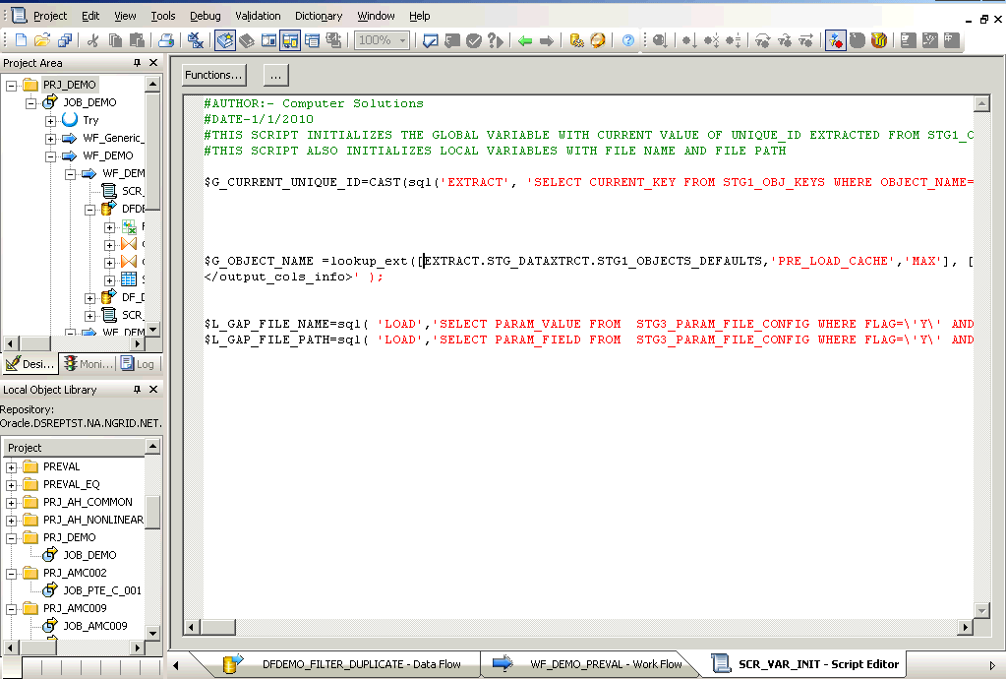

Conditional Demo 
- Evaluate a condition in conditional object & decide course of action. This provides an if-then-else structure only, so multiple conditional may be needed to evaluate if-elseif-else logic.
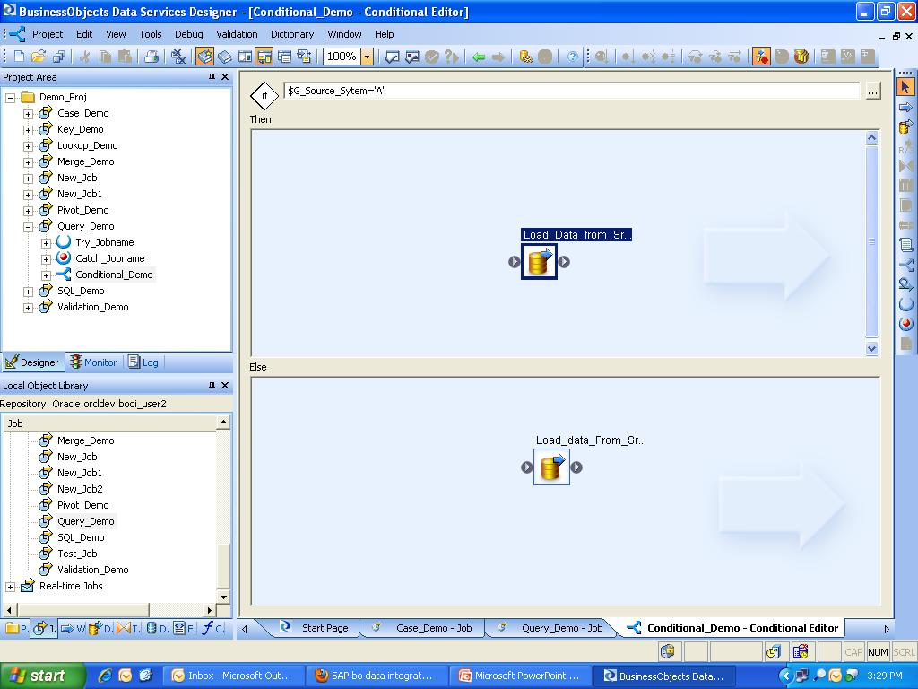
Loop Demo 
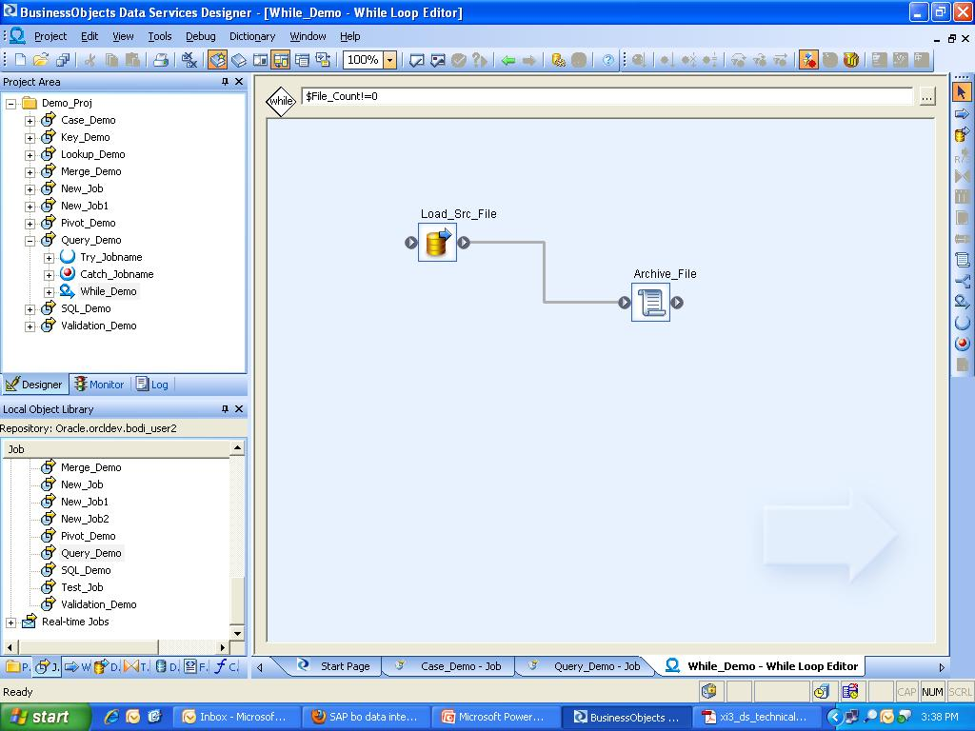

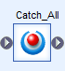
Try Catch Block Demo

- Try Catch block is used to capture error messages in BODI.

DEVELOPER 101
Developer I0I : Transforms
- List of available Transforms
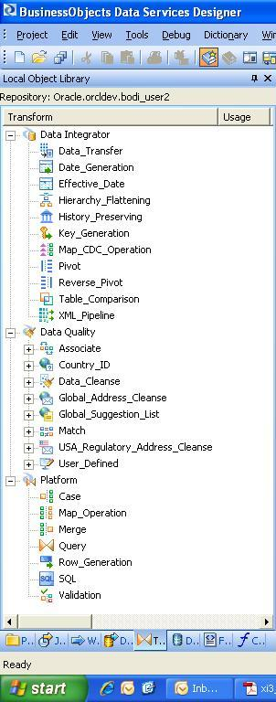

Query Transform
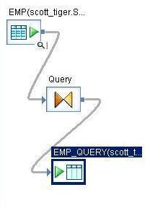
- Query transform is used to retrieve a data set based on the input schema that satisfies conditions that we specify. A query transform is similar to a SQL SELECT statement. The Query transform is used to perform the following operations: -
- Maps column from input Schema to output Schema.
- Perform transformations and functions on the source data.
- Assign Primary Keys to output Schema columns.
- Add New Output columns, Nested Schemas, and Function Calls to the output Schema.
- Perform Data Nesting and Un nesting with Sub Schemas of the Output Schema. Also assign Make Current Schema.
- Generate Distinct result set output for the input Schema.
- Join data from Multiple Input Source Schemas. Equi Join as well as Outer Join is supported.
- Filter input Source Data.
- Performs Aggregation based on input column groups.
- Generate sorted dataset based on source input column order.
- Also, we can generate DTD, XML Schema or File Format based on the Input or Output Schema.

Case Transform
- Case transform is used to divide or route the input data set into multiple output data sets based on the defined logical expression. It is used to implement IF-THEN-ELSE logic at dataflow level. This transform accepts only one source input. We can define multiple labels and their corresponding CASE expression. For input rows that do not satisfy any of the CASE conditions, we may select to output those records using the DEFAULT case. For that we need to select the check box Produce default output when all expressions are false.
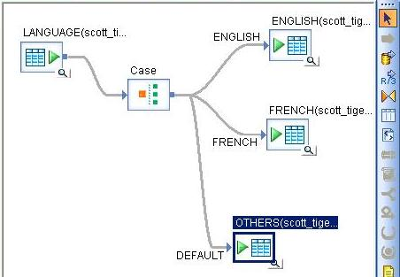
- Two other featured properties of this transform are Row can be TRUE for one case only and Preserve expression order. If we select the option Row can be TRUE for one case only, then a row is passed to the first case whose expression returns TRUE. Otherwise, the row is passed to all the cases whose expression returns TRUE. Preserve expression order option is available only when the Row can be TRUE for one case only option is checked. We can select this option if expression order is important to us because there is no way to guarantee which expression will evaluate to TRUE first.

Merge Transform
- Merge transform is used to combine multiple input dataset with the same schemas into a single output dataset of the same schema. It is equivalent to SQL UNION ALL statement. In order to eliminate duplicate records from output dataset basically to attain UNION operation, add a Query transform with DISTINCT option enabled after the Merge transform.
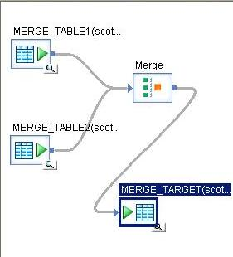

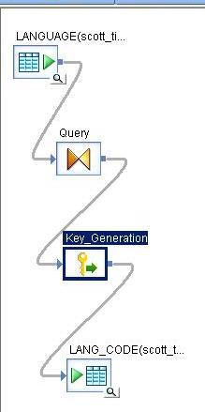
Key Generation Transform
- Key Generation transform helps to generate artificial keys for new rows in a table. The transform looks up the maximum existing key value of the surrogate key column from the table; And uses it as the starting value to generate new keys for new rows in the input dataset. The transform expects a column with the same name as the Generated key column of the source table to be a part of the input schema.

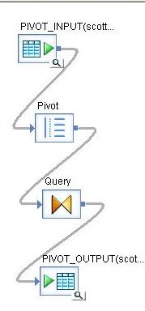
Pivot Transform
- The Pivot transformation allows us to change how the relationship between rows is displayed. For each value in each pivot column, BODI produce a row in the output data set. It basically converts Columns to Rows.

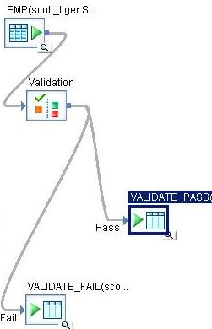
Validation Transform
- Validation transform is used to filter or replace the source dataset based on criteria or validation rules to produce desired output dataset. It enables to create validation rules on the input dataset, and generate the output based on whether they have passed or failed the validation condition. This transform is typically used for NULL checking for mandatory fields, Pattern matching, existence of value in reference table, validate datatype, etc.
- The Validation transform can generate three output dataset Pass, Fail, and RuleViolation. The Pass Output schema is identical with the Input schema. The Fail Output schema has two more columns, DI_ERRORACTION and DI_ERRORCOLUMNS. The RuleViolation has three columns DI_ROWID, DI_RULENAME and DI_COLUMNNAME.
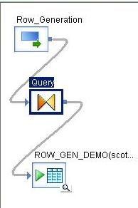
Row Generation Transform
- Row Generation transform produces a dataset with a single column. The column values start with the number that we specify in the Row number starts at option. The value then increments by one to specified number of rows as set in the Row count option. This transform does not allow any input data set.

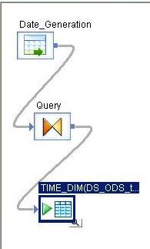
Date Generation Transform
- Date Generation transform is used for creating time dimension tables. This transform generates a column which holds the date values based on the start & end dates provided as an input to the transform by considering the increment provided to it.

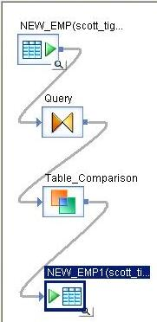
Table Comparison Transform
- Table Comparison transform helps to compare two data sets and generates the difference between them as a resultant data set with rows flagged as INSERT, UPDATE, or DELETE. This transform can be used to ensure rows are not duplicated in a target table, or to compare the changed records of a data warehouse dimension table. It helps to detect and forward all changes or the latest ones that have occurred since the last time the comparison table was updated. We will be using this transform frequently while implementing slowing changing dimensions and while designing dataflows for recovery.
- Apart from all these properties there are three methods for accessing the comparison table namely Row-by-row select, Cached comparison table and Sorted input. Below is the brief on when to select which option.
- Row-by-row select option is best if the target table is large compared to the number of rows the transform will receive as input. In this case for every input row the transform fires a SQL to lookup the target table.
- Cached comparison table option is best when we are comparing the entire target table. DS uses pageable cache as the default. If the table fits in the available memory, we can change the Cache type property of the dataflow to In-Memory.
- Sorted input option is best when the input data is pre-sorted based on the primary key columns. DS reads the comparison table in the order of the primary key columns using sequential read only once.
- NOTE: The order of the input data set must exactly match the order of all primary key columns in the Table Comparison transform.

Lookup Function
- There are three types of lookup functions:
i. Lookup
ii. Lookup_seq
iii. Lookup_ext (most widely used)

- Lookup is the basic plain-vanilla type, which helps you to lookup values but is not as rich as its peers in terms of the options provided.
- Lookup_Seq searches in matching records to return a field from the record where the sequence column satisfies the given conditional operator logic.
- Lookup_ext is the most widely used function and it provides us with a number of options such as being able to specify the return policy, order by logic, caching mechanism, optimization as well as being able to return multiple columns.

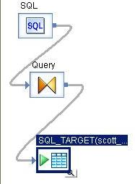
SQL Transform
- SQL transform is used to submit or perform standard SQL operations on database server. The SQL transform supports a single SELECT statement only. This transform does not allow any input data set. Use this transform when other built-transforms cannot perform the required SQL operation. Try to use this transform as your last option as it not optimised for performance and also reduces readability.

More Transforms…
- Some more transforms, refer documentation for details on them!
  - History Preservation
  - Map Operation
  - Data Transfer
  - XML Pipeline
  - Hierarchy Flattening
  - Effective Date

Developer I0I : Functions
- Key categories of functions include the following
  - String / Date / Math Functions
  - Lookup
  - Aggregation
  - Validations/Conversion
  - Environment Functions
  - Custom Functions
Developer I01: File Formats
- File Formats provide a way to interact with source/target systems which occur as files.
- The files can occur in the following
formats, types
  - Flat files: Fixed width, Delimited
  - XML Schemas & DTD’s
  - Microsoft Excel Spreadsheets
  - Cobol Copybooks

Developer I0I: Variables
- Variables Serves as place holders for that they may not be available or change throughout the job execution. They can be of the Following types
- Global Variables
- Local Variables
- Global Variables: These are created at the Job Level and used anywhere in the job and visible across all the components in the job.
- Local Variables: These are created at the Work Flow/Data Flow Level and will be visible where they have been created.

Developer I0I: Parameters
- Parameters are used to pass the values between the Jobs/Parent Work Flows and child Work Flows/Data Flows
- Parameters are of two types they are:
- Input
- Output
- We can the Variables/Parameters at the following Levels:
- Job Level – Global Variables and Local Variables
- Work Flow Level – Local Variables and Parameters
- Data Flow Level – Only Parameters

ADVANCED CONCEPTS
- Substitution Parameters are used to parameterize environment or repository specific information required for job execution. These values are constant during job execution and change with change in environments only. Substitution Parameters are defined with by prefixing $$ to their name.
- System Configuration is a collection of data store profiles values and substitution parameter configuration in use with a particular job execution.

Auditing
- Auditing is available in Data Services to aid tracing the flow of data from source(s) to target(s). You can define which aggregation/checksum functions to be used for generating audit labels. Using these labels, audit rules can be defined for your dataflow.
Recovery
- Unsuccessful job execution is a common occurrence and like every major ETL tool Data Services provides a set of recovery mechanisms to complete target loads reliably.
  - To enable automatic recovery for the job, select enable recovery option in the execution properties. With this option, all steps in the job execution are recorded.
  - Upon failure, rerun the job in recovery mode. DS remembers the steps from previous execution now and will only execute the failed steps again.
  - Certain objects must be run in conjunction to make sense. While using automatic recovery, one must group these objects in a workflow and make it Recovery Unit. This way, DS runs the whole workflow if the failure occurred in the workflow.
  - Note: You cannot change the job itself while recovering from failure.

TEAM BASED DEVELOPMENT
Team based Development: Central Repository (It serves the following functions in DS deployment)
  - Collaboration between developers
  - Configuration Management
  - Code Migration/ Deployment
  - Central Repository can also store multiple versions of the projects/jobs unlike the local repository which stores the current version only.

Adding Object to Central Object Library
  - Right Click on any object in Local Object Library and select the option ‘Add to Central repository’ as shown below.
  - Option ‘Add to Central repository’ will be disabled if object already exists in Central Object Library

Adding Object and Dependents/Object
By using this option the object/object along with its dependents is/are added to
Central Repository.
- Comments need to be entered for each object that is being added.
- ‘Apply to All’ option can be selected if the comment is applicable to all dependent objects in an object that is being added.
- ‘Apply to All’ option is available if the ‘Object and Dependent's option is selected.

Adding Object – With filtering
  - This option provides the option to create/replace/exclude any dependent object from adding to Central Object library.
  - Any one of the Create/replace option is available.
Check Out from Central Object library
- Right Click on any object in Local Object Library and select the option ‘Check Out’ as shown below.
- Option disabled if already checked out to another repository.

Check Out – Object
- Option available for all types of objects
- Usually done for projects, tables and file formats.
- In some cases, data flows and work flows can also be checked out using this method.
- Replaces the object available in the Local Object library with the latest copy available in the Central Object Library.
- Option used when it is confirmed that the latest code is available in Central Object Library.

Check Out – Object without replacement
- Option available for all types of objects
- Usually done for projects, tables and file formats.
- Does not Replace the object available in the Local Object library with the latest copy available in the Central Object Library.
- Option used when you are not sure that the latest code is available in Central Object Library.
Check Out – Object and Dependents
- Option available for jobs, workflows, data flows, data stores, projects, custom functions.
- Option not available for individual tables, file formats.
- Replaces all the object and its dependent objects in Local Object library with the latest copy of the objects available in the Central Object Library.
- Option used when it is conformed that the latest code for the object and its dependents is available in the Central Object Library.
Check Out – Object and Dependents without replacement
- Option available for jobs, workflows, data flows, data stores, projects, custom functions.
- Option not available for individual tables, file formats.
- Does replace all the object and its dependent objects in Local Object library with the latest copy of the objects available in the Central Object Library.
- Option used when you are not sure that the latest code for the object and its dependents is available in the Central Object Library.
Check Out – With Filtering
- Option available for all types of objects
- Usually done for projects, tables and file formats.
- In some cases, data flows and work flows can also be checked out using this method.
- Replaces the object available in the Local Object library with the latest copy available in the Central Object Library.
- Data Stores can be checked out using this method.
- The dependent Objects can be included/excluded from the Check Out list using this option.
- Option used to check out partial code from Central repo as the latest code is available in Central Object Library.
- Gives the option to exclude code at a project level so only code (multiple Dataflows, Workflows) to be changed is checked out.

Check in into Central Object Library
- Right Click on any object in Local Object Library and select the option ‘Check In’ as shown below.
- Option disabled if already checked in to Central Object Library.

Check In – Object
- Option available for all types of objects
- Usually done for projects, tables and file formats.
- In some cases, data flows and work flows can also be checked in using this method.
- Replaces the object available in the Central Object library with the latest copy available in the Local Object Library.
- Option used when it is confirmed that the latest code is available in Local Object Library and needs to be available in Central Object Library.

Check In – Object without replacement
- Option available for jobs, workflows, data flows, data stores, projects, custom functions.
- Option not available for individual tables, file formats.
- Replaces all the object and its dependent objects in Central Object library with the latest copy of the objects available in the Local Object Library.
- Option used when it is conformed that the latest code for the object and its dependents is available in the Local Object Library and the same need to be available in Central Object Library.

Check In – With Filtering
- Option available for jobs, workflows, data flows, data stores, projects, custom functions.
- Option not available for individual tables, file formats.
- Replaces all the object and the selected dependent objects in Central Object library with the latest copy of the objects available in the Local Object Library.
- Data Stores can be checked in using this method.
- Option used when it is confirmed that the latest code for the object & its dependents is available in Local Object Library & the same needs to be available in Central Object Library.
- The dependent Objects can be included/excluded from the Check In list using this option.

Get Latest Version from Central Object Library
- Right Click on any object in Local Object Library and select the option ‘Get Latest Version’ as shown below.

Get Latest Version – Object
- Option available for all types of objects
- Usually done for projects, tables and file formats.
- In some cases, getting latest version of dataflow & workflow can be done using this method.
- Replaces the object in the Local Object Library with the latest copy of code available in the Central Object Library.
Get latest Version – Object and Dependents
- Option available for jobs, workflows, data flows, data stores, projects, custom functions.
- Option not available for individual tables, file formats.
- Replaces the object and its dependents in the Local Object Library with the latest copy of code for these objects available in Central Object Library.

Get Latest Version – With Filtering
- Option available for jobs, workflows, data flows, data stores, projects, custom functions.
- Option not available for individual tables, file formats.
- Replaces all the object and the selected dependent objects in Local Object library with the latest copy of the objects available in the Central Object Library.

Show History for an Object
- Right Click on any object in Local Object Library and select the option ‘Show History’ as shown below.

Compare Option
- Right Click on any object in Local Object Library and select the option ‘Compare’ as shown below.

CODE MIGRATION
Deployment Package (usually a zip file) needs to be created which contains ATL, XML, DDL & DML file, which is used to promote code from one environment to another environment via various tools.

WEB ADMINISTRATION
- The web admin console can be accessed through the following URL : http://<DS Server M/C IP>:28080/DataServices/. To execute functions for your repository, you need to register your local repository using management module in web admin.
Administrator
Web-based Operational Administration of Data Services includes:
- Scheduling, monitoring and executing batch jobs
- Configuring, starting/stopping real-time services
- Configuring Job Server, Access Server, server groups and repository usage
- Configuring and managing adapters
- Managing Central Repository user’s groups & access
- Access to data validation, auto documentation, impact & lineage analysis, operational dashboards

Admin: Repository Registration
- Repositories can be registered to the Web Admin by entering repository details on the
management module.
- User & Groups for Secure Central repositories can be created using the Central Repositories menu on Web admin, post registering the central repository on Web admin.

Admin: View Logs
- Click on the repository name to view logs associated with jobs in your repository.

Admin: Scheduling
- Click on the batch job configuration tab to setup /edit schedules for your jobs, however the scheduling support is very limited in DS.
- A useful alternative is to use export execution command and schedule this invocation externally.
Admin: Auto Documentation
- Auto Documentation feature on Web Admin console provides an elegant way to document ETL jobs. The document can be crated in MS Word or Adobe PDF formats and covers attribute level transformation details as well.

BODI BEST PRACTICES

- Parallel Threads in Query
- Intensive use of Query Transform
- Degree of Parallelism
- Use of parameterization
- Use temporary tables as data structures change very often
- Always check Monitor Log for failures (Sometimes Green status jobs can also fail)
- Collect Statistics and correlate to source and target data
- Never check out Datastores
- Always use proper naming convention
- Always maintain a flow of any object build (Each object should have 3 jobs, Construct/legacy pull, Map/Load, Post load job)
- Usage of indexes whenever data volume is high to improve performance
- Usage of joins and filter conditions whenever data set is high
- If extracting data from SAP, use SAPR3 transformation.
Also, if extracting large volume of data from SAP, use filter conditions on direct pull from SAP to target without any other transformations.

