ABAP DATAFLOW:
Create a Project :-> PRJ_DIM_ABAP

Create a Job ->JB_XRX_RG_DIM_POSTING_KEY
Create a script -> It will hold all the global and local variable declarations.
Create a Workflow -> WF_XRX_ECC_DIM_POSTING_KEY
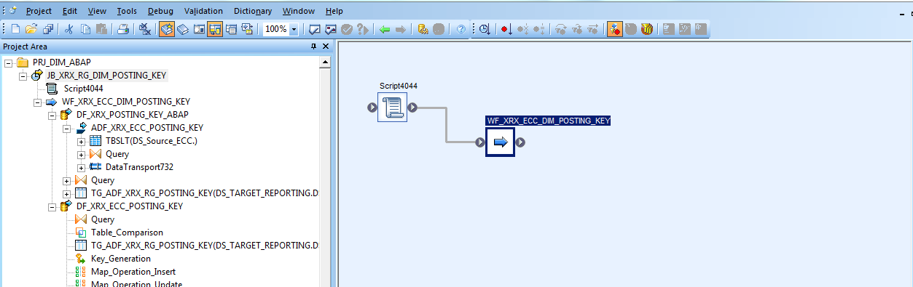

In Workflow Create a Dataflow ->DF_XRX_POSTING_KEY_ABAP

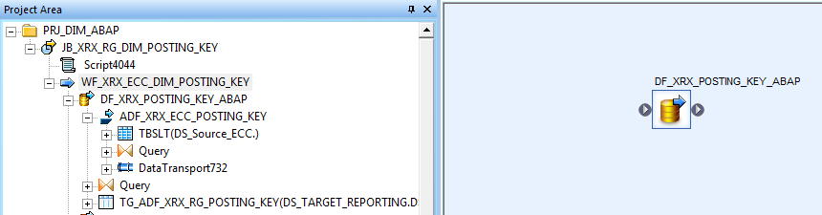

In the dataflow Create an ABAP Dataflow ->ADF_XRX_RG_POSTING_KEY

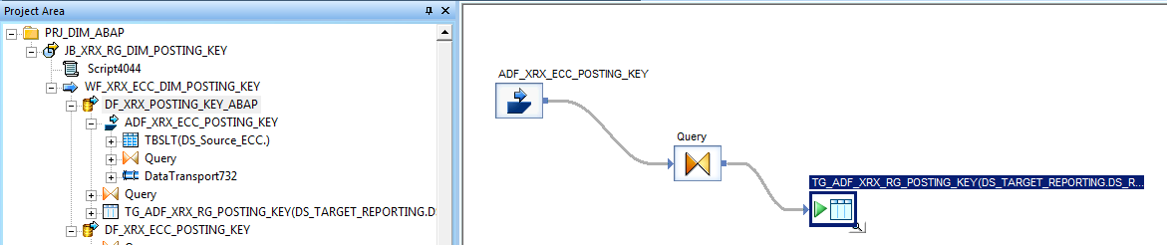

Double Click the ABAP Flow 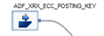and then

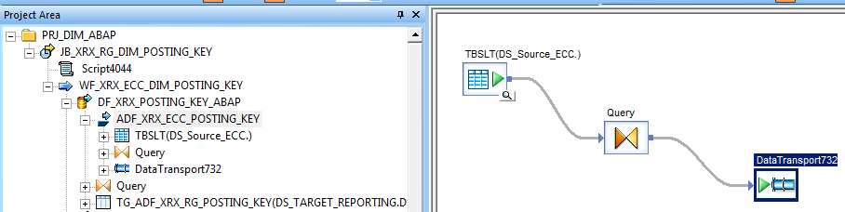

Drag a source table ->TBSLT(DS_Source_ECC)

Write a Query ->Query

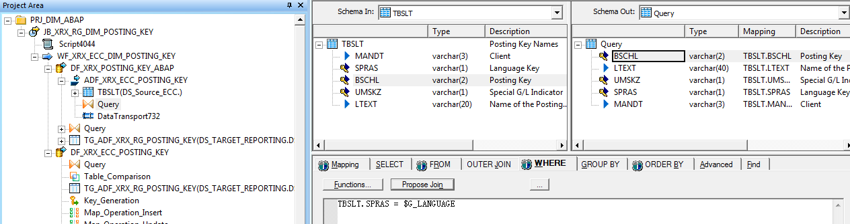

Send target to ABAP Transport ->DataTransport732
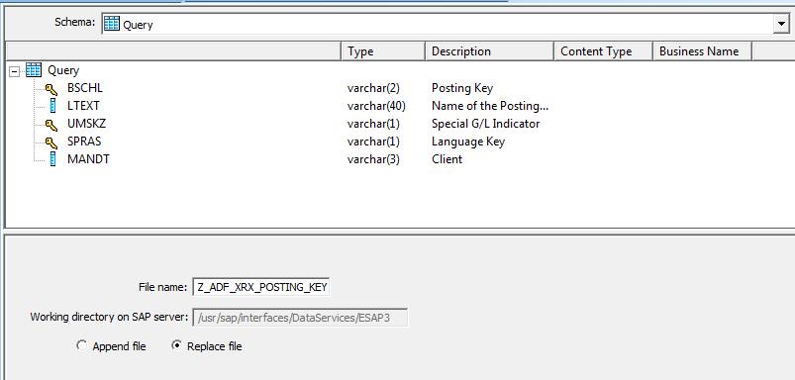

Enter the file name starting with alphabet ‘Z’

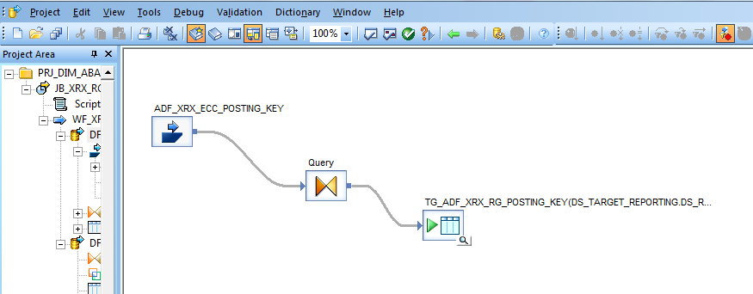

Query the Output of ABAP Dataflow ->Query
Send it to a target Table ->TG_ADF_XRX_RG_POSTING_KEY(DS_TARGET_REPORTING.DS_REPORTING)

Execute the JOB to create the ABAP dataflow output(TG_ADF_XRX_RG_POSTING_KEY) as the template table under the DS_TARGET_REPORTING datastore.

Second Dataflow : DF_XRX_ECC_POSTING_KEY is created to use the ABAP dataflow output(TG_ADF_XRX_RG_POSTING_KEY) template table as source table, for this drag the file as source from the template tables list under the DS_TARGET_REPORTING Data store

In the first dataflow we have written the ABAP flow to extract the table through SAP application. By following the above steps we have got the data from the SAP Application table in a Template table which we can access from the Template Tables under the Data store now To use the APAB flow output as source input table create a second dataflow:

Create the Dataflow: >DF_XRX_RG_DIM_POSTING_KEY

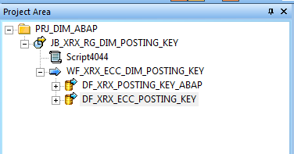

And this dataflow will contain the following components:

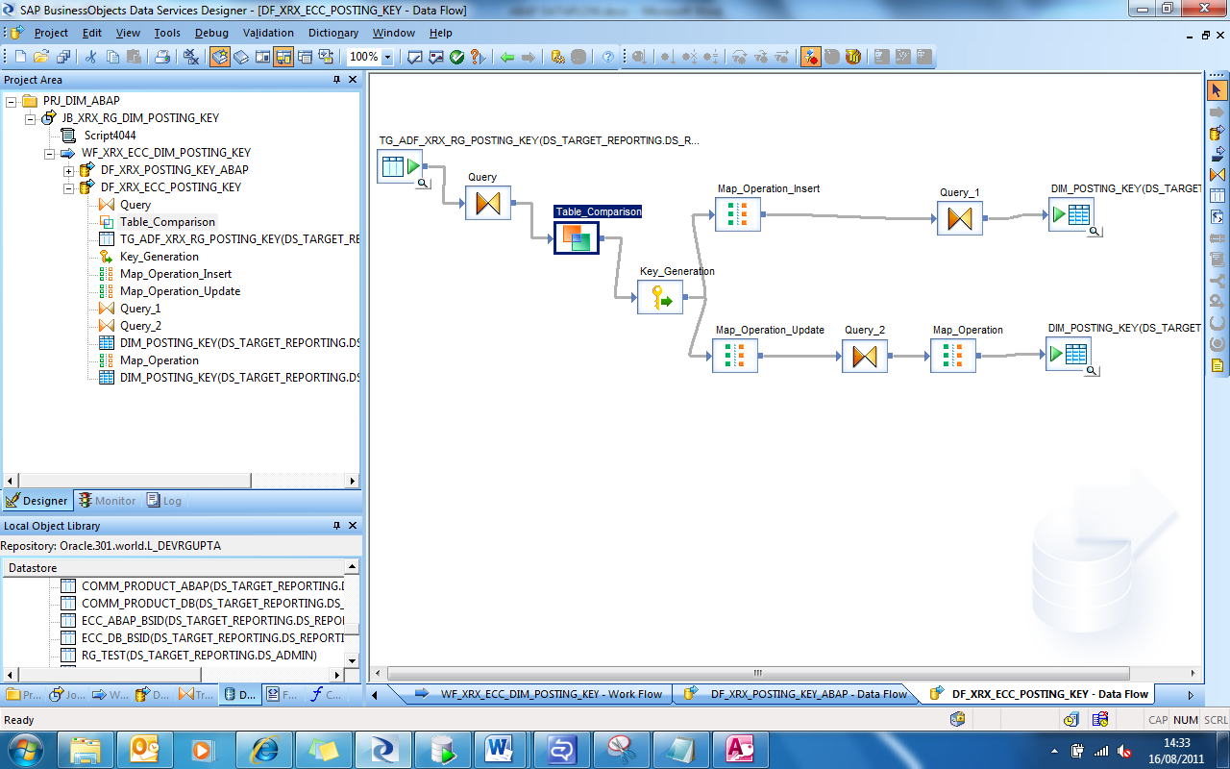
3
4
5
6
7
8
9
10
11
1
2

1
is a source table (output of the ABAP extract) TG_ADF_XRX_RG_POSTING_KEY

2
is Query : Select the fields from the input table which we want in the Schema Out Query, Provide the required conditions under the
WHERE tab and the primary key under the ORDER BY tab.
Set the Primary Key to Ascending in the Order by tab if we want to do table comparison with the sorted output.

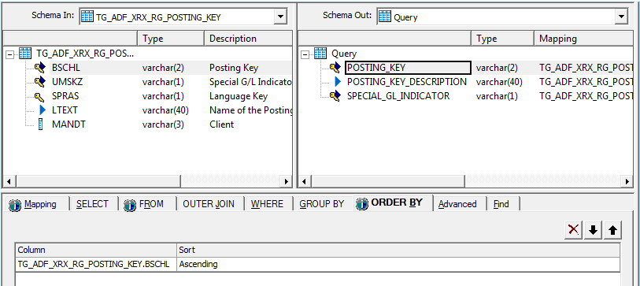

3
Table Comparison:
Compares two data sets and produces the difference between them as a data set with rows flagged as INSERT, UPDATE, or DELETE.The Table_Comparison transform allows you to detect and forward changes that have occurred since the last time a target was updated.
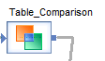double click on it, define the fields and tables as below:

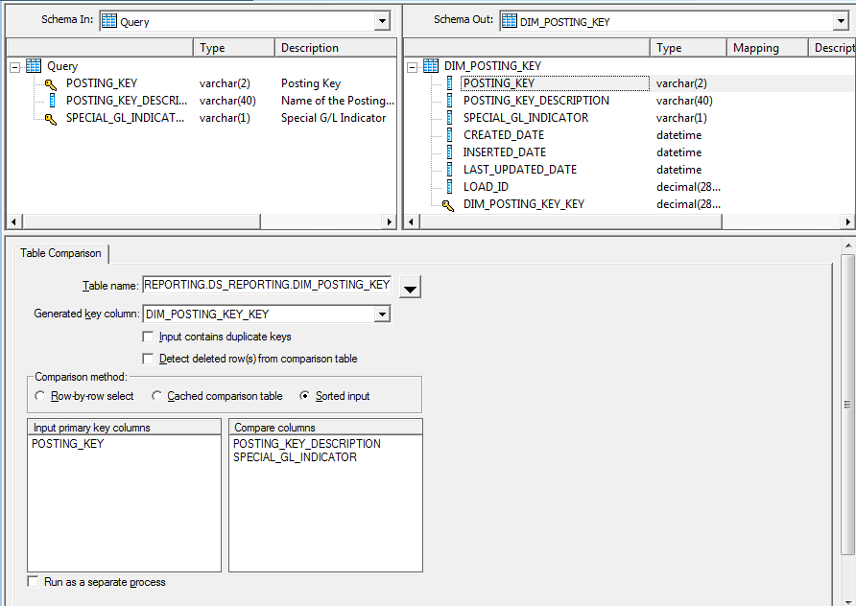
This table is a dimension table created in Oracle via Oracle SQL Developer.
We have the same table name in table comparison because we have to either update or insert the changes happened in the same table.
This is Key field we create while creating table structure in oracle which represent Key field in data services.
If this is selected make sure in the Query we have set the Primary key under the OrderBy tab.

Before dragging the columns to the ‘Input primary Key column’ and to ‘compare columns’ change the column name for the fields in the Schema in Query, to do this; double click the column in Schema out field like Posting Key and then go back to Query click the same fields for which we want to change the name and paste the name we copied from the table comparison table. Repeat the same for all the fields.
Once done drag the fields to ‘Input primary key column’ and ‘compare column’.
Example of Table comparison : here Opcode column means Operation code.(operation may be insert, update or delete)
In case of insert:
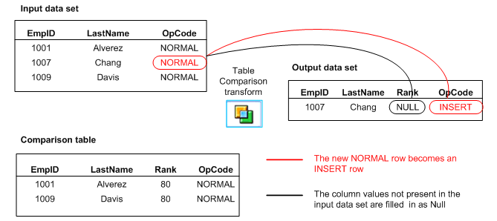
In case of Update:
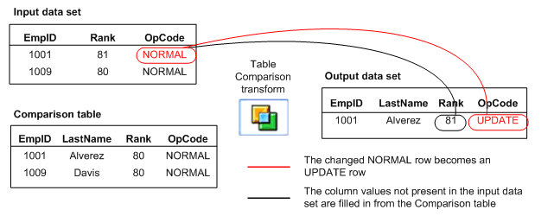
In case of Delete :
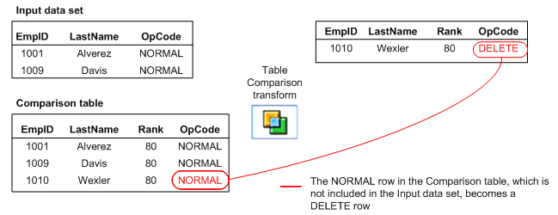
Output dataset now contains the rows with the flag as OpCode for insert, Update or delete.

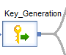
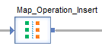4
Generates new keys for new rows in a data set.

When it is necessary to generate artificial keys in a table, the Key_Generation transform looks up the maximum existing key value from a table and uses it as the starting value to generate new keys. The transform expects the generated key column to be part of the input schema.

The data set includes a column into which generated keys are added. For example DIM_POSTING_KEY_KEY

A data set that is the result of a comparison between two images of the same data in which changed data from the newer image are flagged as UPDATE rows and new data from the newer image are flagged as INSERT rows.

The data set includes a column into which generated keys are added.

5
Allows conversions between data manipulation operations.
The Map_Operation transform allows you to change operation codes on data sets to produce the desired output. For example, if a row in the input data set has been updated in some previous operation in the data flow, you can use this transform to map the UPDATE operation to an INSERT.
The result could be to convert UPDATE rows to INSERT rows to preserve the existing row in the target.

Data Services can push Map_Operation transforms to the source database.
Data Inputs for the map operation is A data set with rows flagged with any operation codes.
the DISCARD option can be assigned. Discarded rows are not passed through to the output of the transform

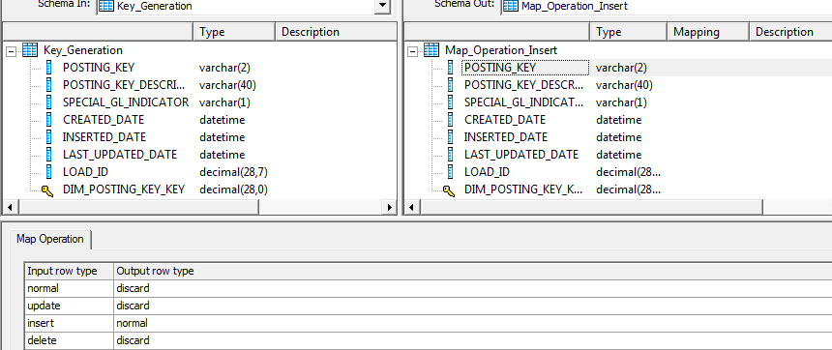

6
Transform or Query to actually insert the new data in the table and for the map operation we will only pick the rows which are
needed to be inserted and rest will be discarded.

Change the Inserted _date (on which the record has been instered in DS) and Last_updated date (Date on which the particular row has been updated last timer in DS) mapping to SysDate().

And set the LOAD_ID to the $G_Exec_ID (a global variable which has been created and defined within the project)

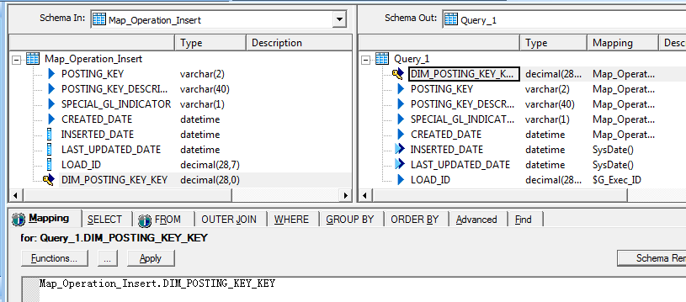

We have create the template table for Dimension POSTING_KEY in the Oracle SQL with name DIM_POSTING_KEY before Table
7
Comparison and because we will always update or insert in the same table DIM_POSTING_KEY we will drag it as Target Table.

8
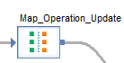
This is a map operation for the Update.
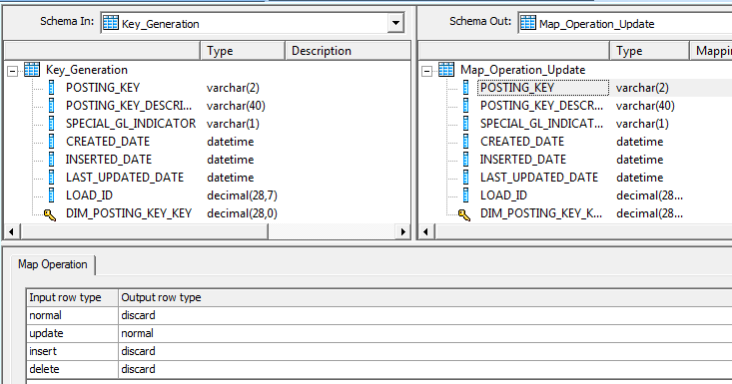

So under the Map Operation tab we are doing normal Update and rest is discarded.
9

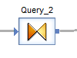

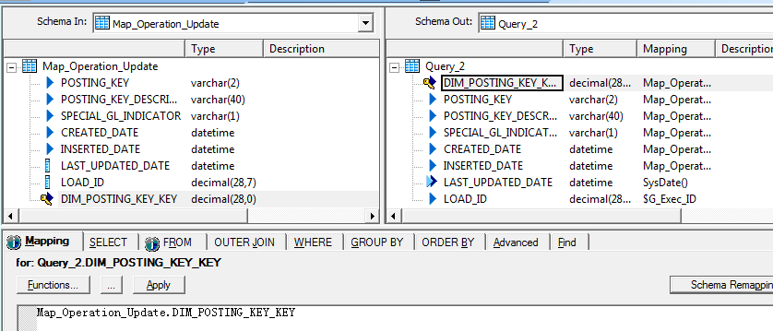

This query is just for update so just update the Last Updated Date ton system date SysDate() and set the LOAD_ID to $G_Exec_ID
10
We redo the mapping operation to actually update the rows.

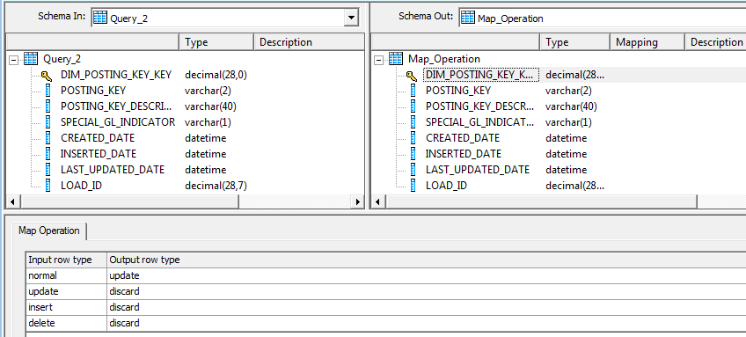
And here for the Map operation tab we set input row type as normal but the operation to be update.

11

Output of the above mapping will goto the Target output; We have create the template table for Dimension POSTING_KEY in the Oracle SQL with name DIM_POSTING_KEY before Table Comparison and because we will always update or insert in the same table DIM_POSTING_KEY we will drag it as Target Table.

Validate and Execute the job data will be in the Target table.

