Metadata of the RFC shows it as time Datattype
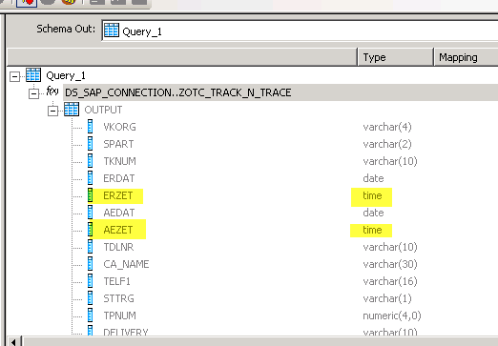
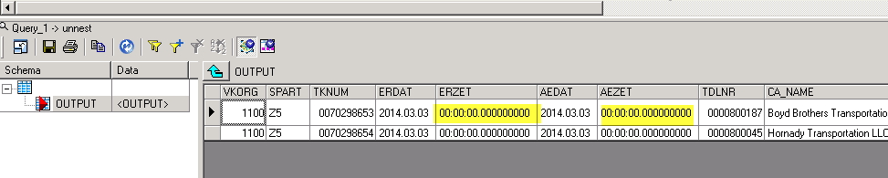
Output of RFC when run in Sap ECC
