Actual Report Structure

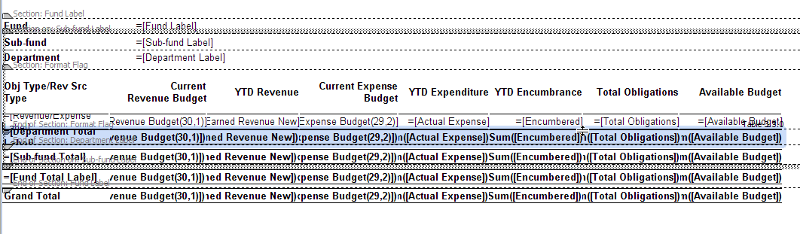

Report Structure After hit Edit Report →View Structure (Whole Structure is disturbed)

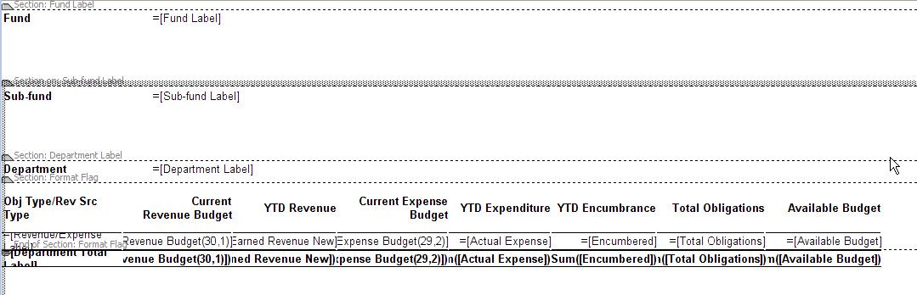

As you see the structure of report is fine in the First image and in Second image when I click Edit Report and click View Structure the whole report structure is disturbed.
I wanted to know if this is the common thing when we hit Edit Report → View Structure.
Or is there any thing I can change so that the report structure is not disturbed.

