Report Data Providers:

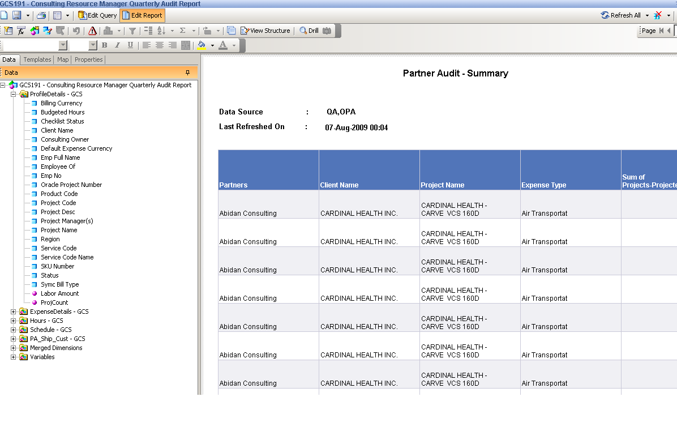
2nd Data Provider:

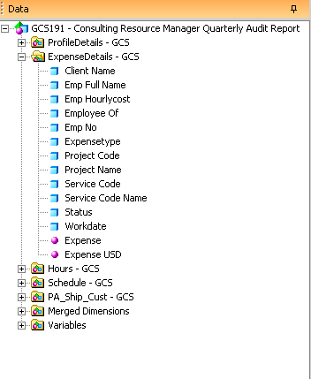

3rd Data Provider:

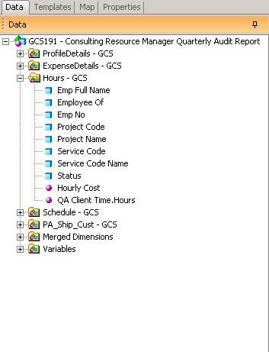

4th Data Provider:

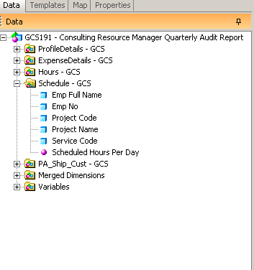

5th Data Provider:

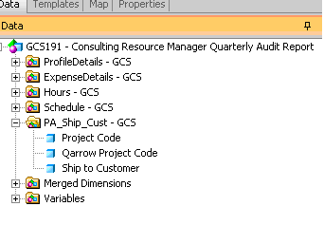

Merged Dimensions:

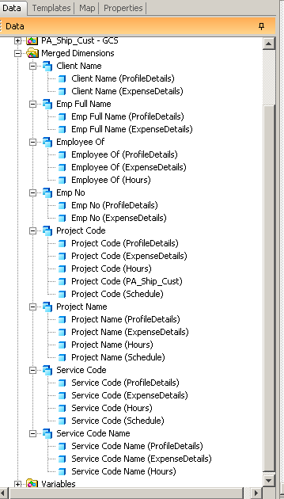
Variables:

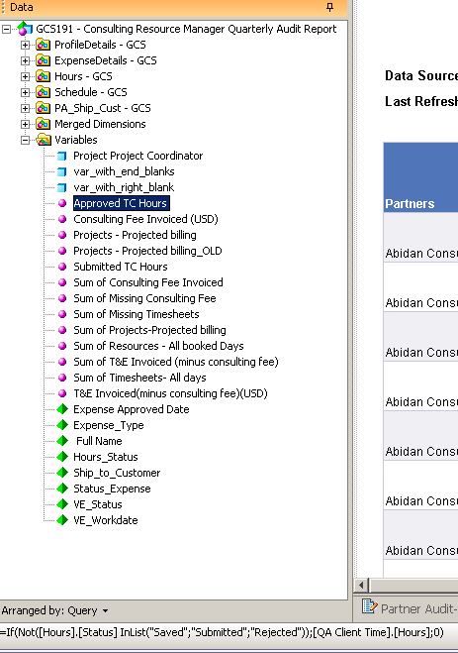.

Variable Definitions:

Consulting Fee Invoiced (USD)=If([Expense_Type]="Consulting Fee";[Expense];0)

Projects - Projected billing=[Emp Hourlycost]*[Scheduled Hours Per Day]

Submitted TC Hours=If([Hours].[Status]="Submitted";[QA Client Time].[Hours];0)

Sum of Consulting Fee Invoiced=Sum(If([Expensetype]="Consulting Fee";[Expense];0))

Sum of T&E Invoiced (minus consulting fee) =Sum(If([Expensetype]<>"Consulting Fee";[Expense];0))

T&E Invoiced(minus consulting fee)(USD)=If([Expense_Type]<>"Consulting Fee";[Expense];0)

