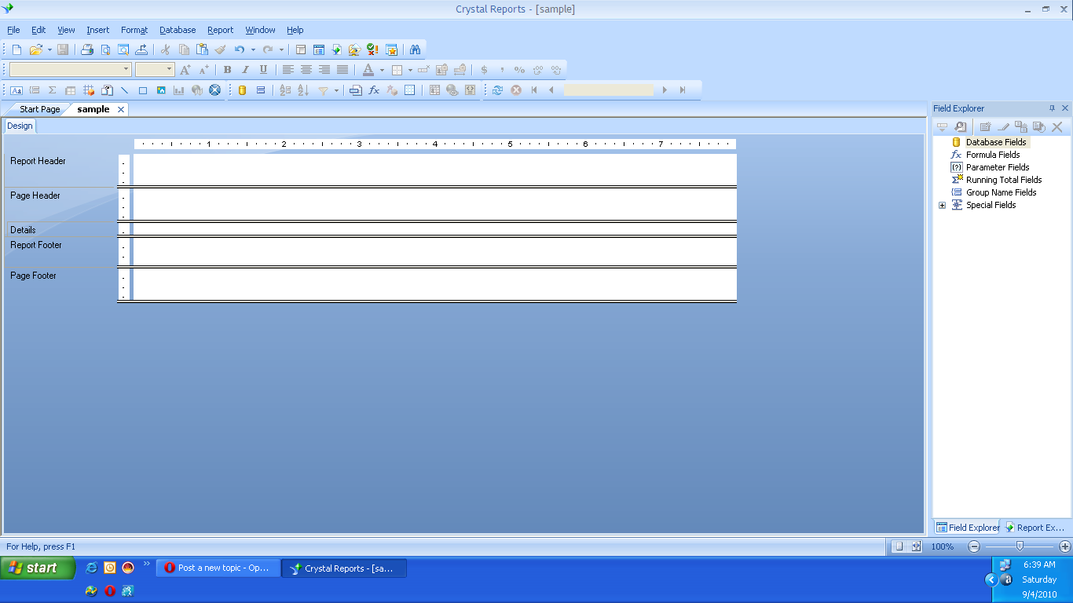
Report Footer comes first in this view.I think it should be after Page Footer.
Page Footer comes after Report Footer.I think It should be after Details.

