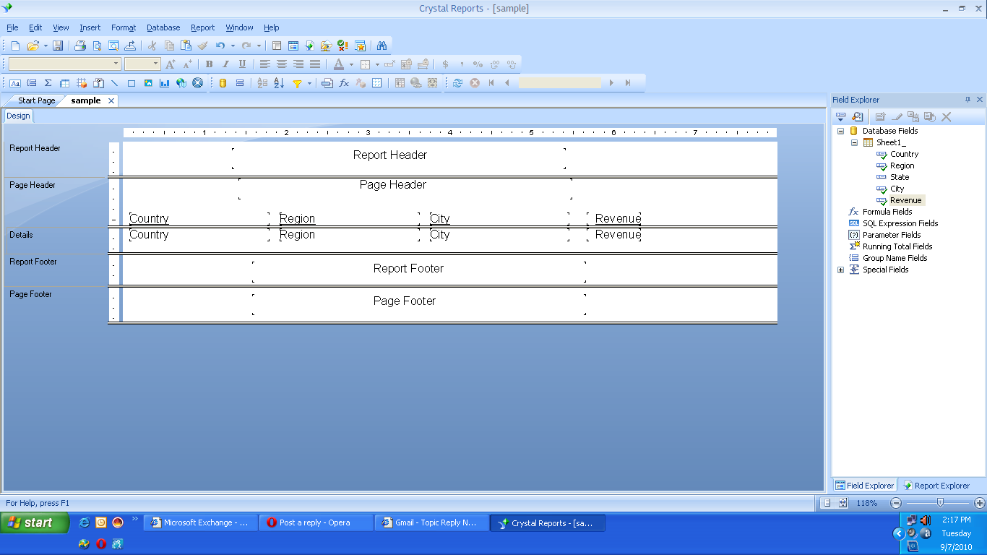

Above one is Design View.

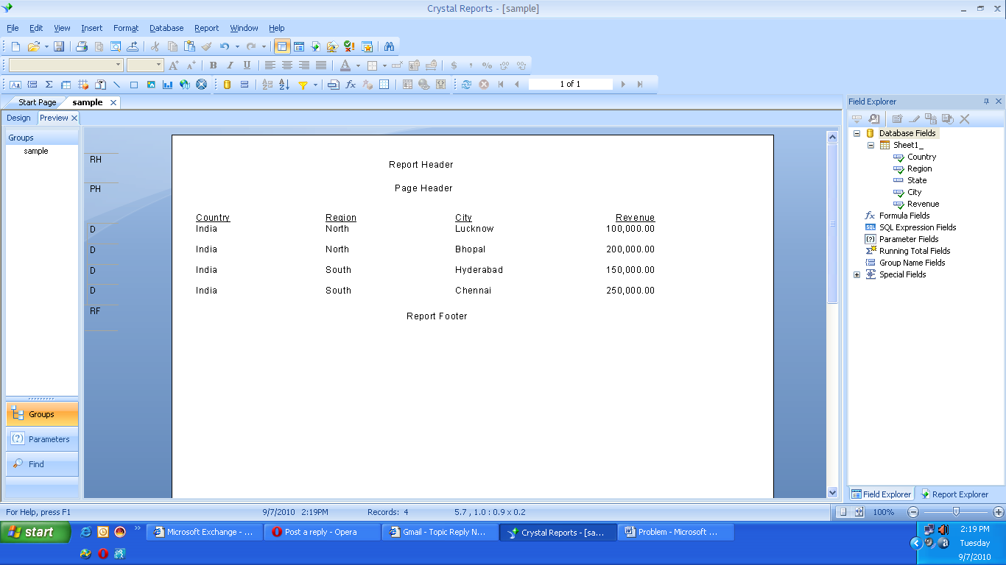

Above one is Report View.

Please find the difference :I have given content for Page Footer in Design View but it is not being displayed in Report View.

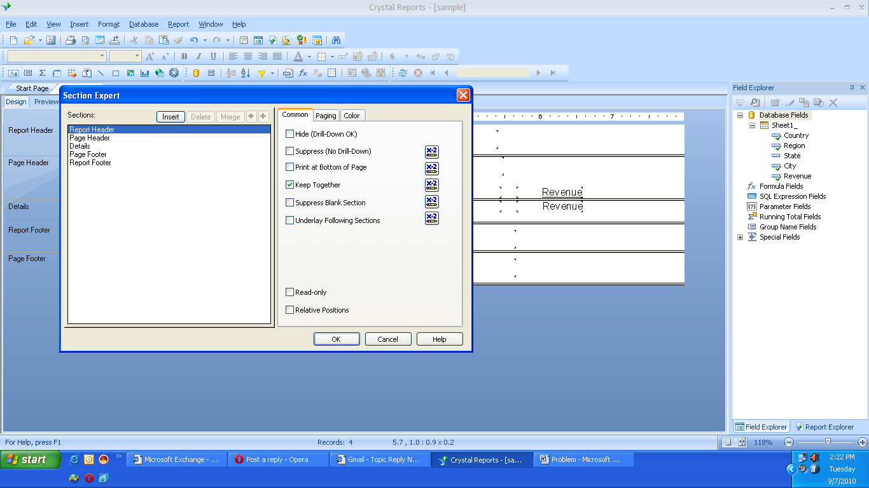

Please observe above Screen shot:you can find the difference in orders in design view and Section Expert.

