Option1:
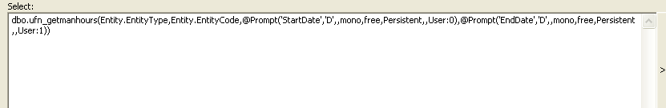

Option 2
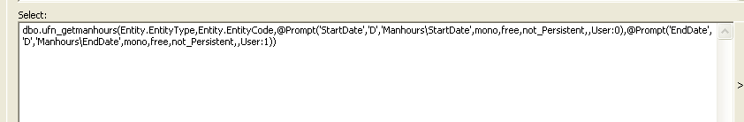

Option 3
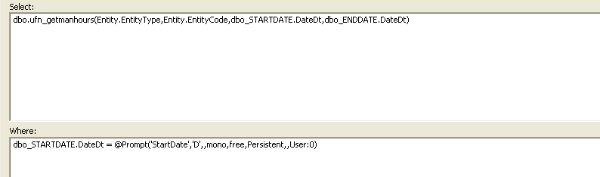

Option 4

