Query Data

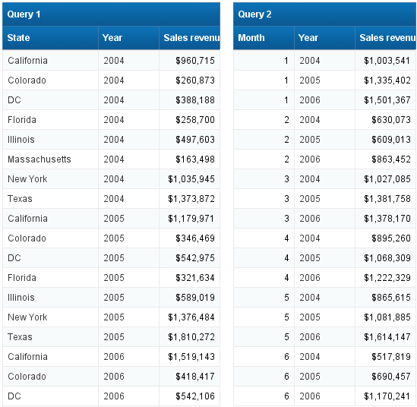

Merged the Year dimension in both the queries:
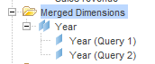

Create detail variables for the State and month dimension
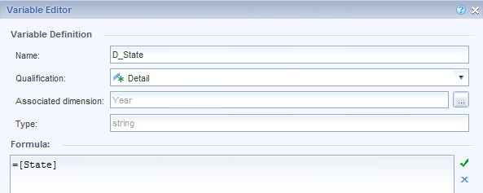

Output table:

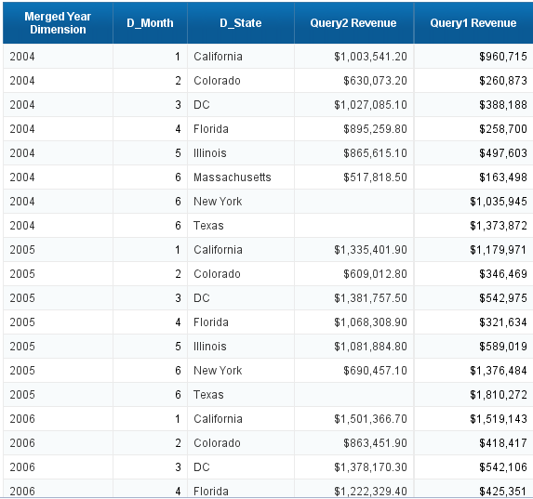

Note: On the table property, enable Avoid duplicate row aggregation. The data will turn up without any Multivalue.

