- User U_Schedule belonging to the group Administrators
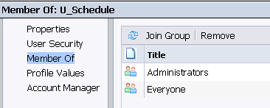
- Login with U_Schedule in CMC, and schedule the report “World Sales” every minute
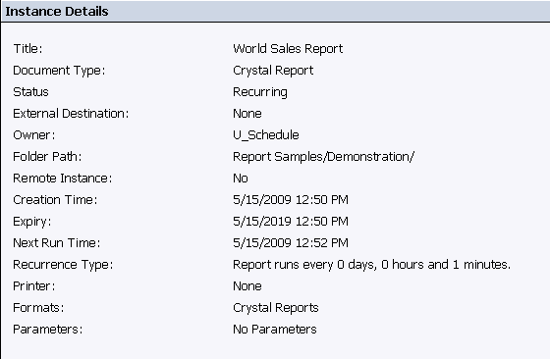
- You will see 1 recurring instance, and a successful instance every minute
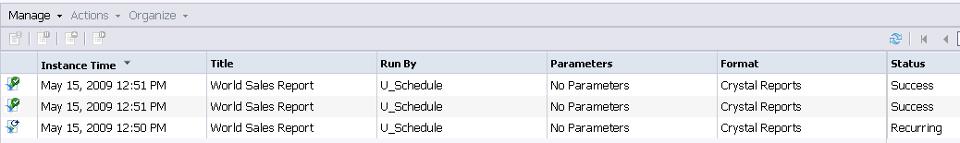
- Now remove the user U_Schedule from the group Administrators
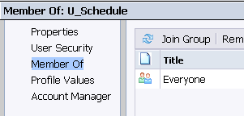
- The recurring schedule has disappeared, only a failed schedule

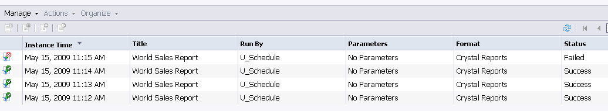

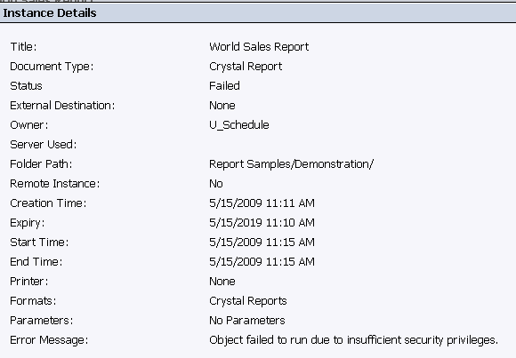

The error is logic (no longer belonging to Administrators), but why is the recurring job gone???

Added the user U_schedule back to the Administrator group, unfortunately nothing happens

