Live Office – Insert Crystal report with main report and subreport.
In picture below is the Crystal report – main report on top, subreport on bottom
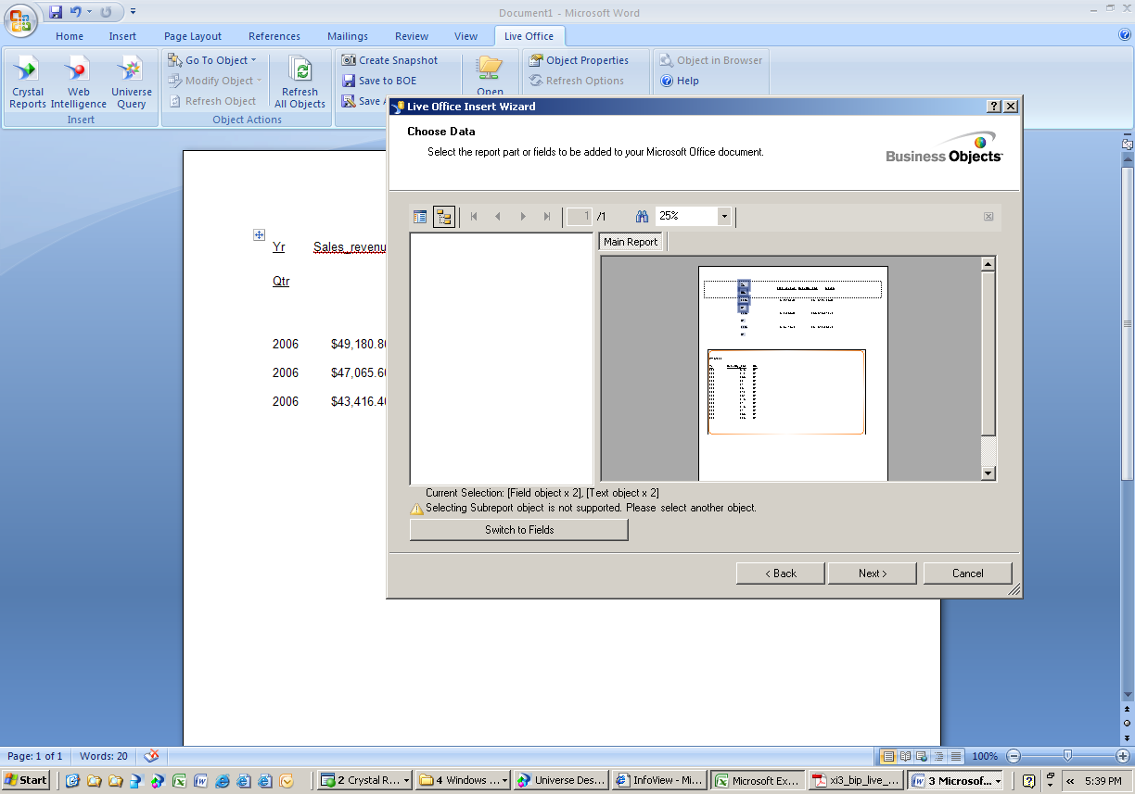
This Main report imports ok

This subreport will not import to work

Imported data into Word document below – only main report is imported

