1
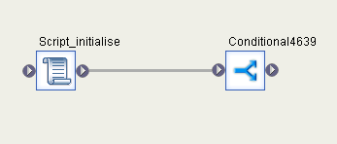
2.
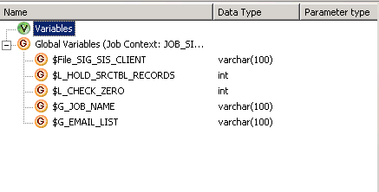
3. Script_Initialise
#########################################
# Checking the source table DATA Count #
#########################################

$L_HOLD_SRCTBL_RECORDS=sql('DS_SIG_SIS_SpectrumPlatinum_Report','select count(1) from SPECTRUMPLATINUM_REPORT');
print(' System Source Data is :'||$L_HOLD_SRCTBL_RECORDS);

###################################################
# Check whether the SIS System has data available yet #
###################################################
$L_CHECK_ZERO = sql('DS_SIG_SIS_SpectrumPlatinum_Report', 'SELECT COUNT(*) FROM SPECTRUMPLATINUM_REPORT');
Print ('SQL to be submitted is: ' || $L_CHECK_ZERO) ;
# E-Mail distribution list if the input data is unavailable.
# Initialize Job Name
$G_JOB_NAME = job_name();

Print('Initializing email list');

$G_EMAIL_LIST ='mahkan@sa.co.uk; rajnia@sa.co.uk’;

4.
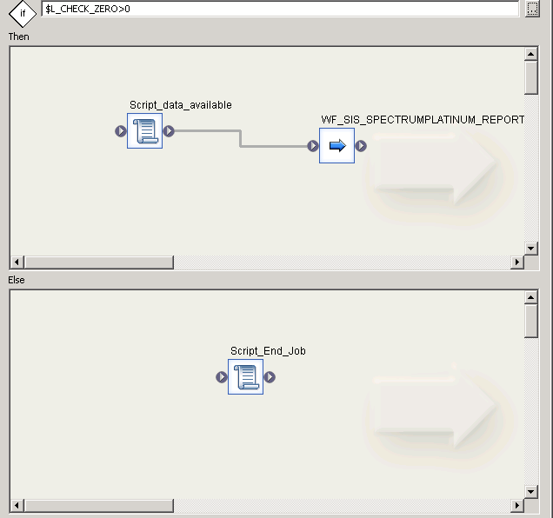

5. Script_data_available
Print('Heading for Loads as the data available in the Source System');
6.
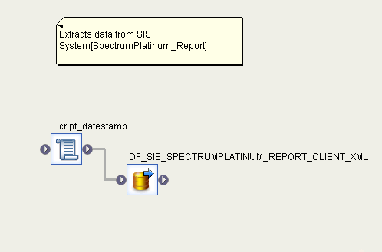
7. Script_datestamp
$File_SIG_SIS_CLIENT= '\\\INSOBODLI01\TGT_XML\TGT_SIG_SIS_CLIENT'||'_'||to_char(sysdate(),'YYYYMMDD')||'.'||'xml';
PRINT('FILE NAME IS:'||$File_SIG_SIS_CLIENT);
8.
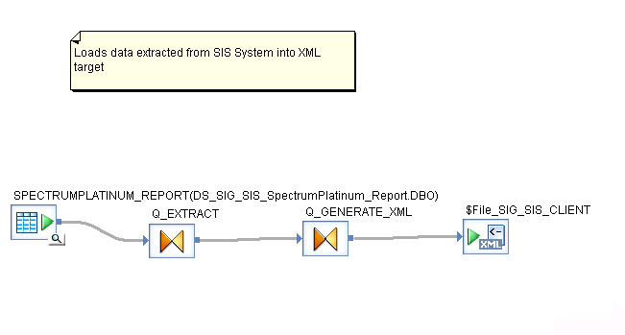

9.
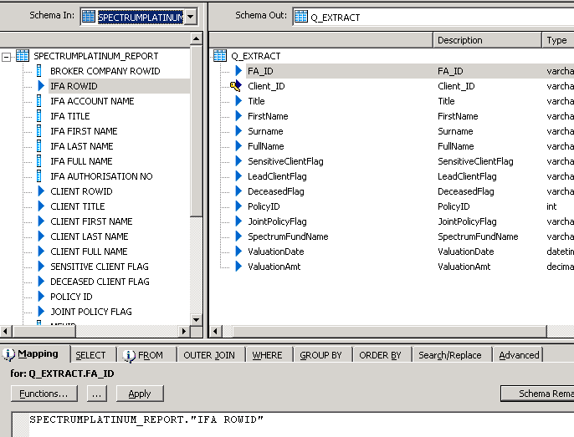
10.
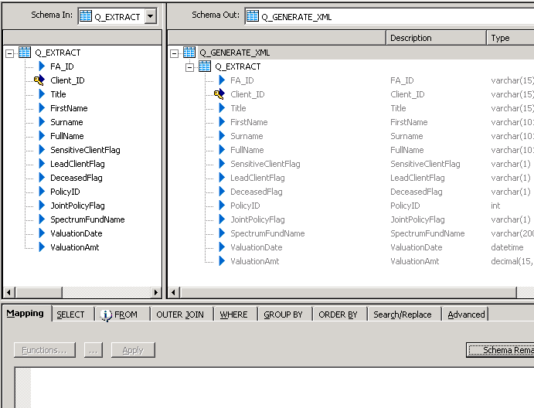
11. Important step.
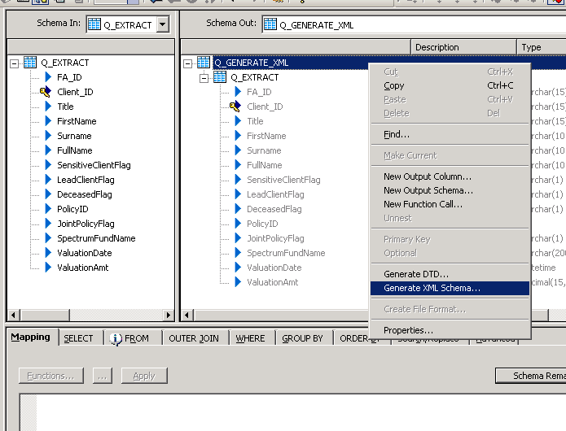
12.
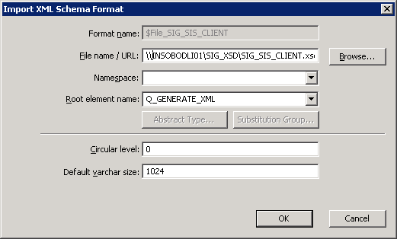
13. Script_End_job

print('Job Ended as there is no data in Source System');
print('Triggering mail to DL');
SMTP_TO($G_EMAIL_LIST,'*** SOURCE DATA UNAVAILABLE-JOB ENDED '||$G_JOB_NAME||' ***', 'Please find details below',10,300);

raise_exception_ext('No Input Data',1);
LOGS:
Note the End time of the first job under issue’JOB_SIS_SPECTRUMPLATINUM_REPORT_CLIENT_XML’
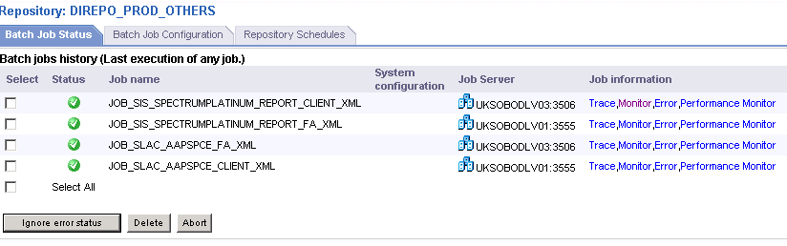
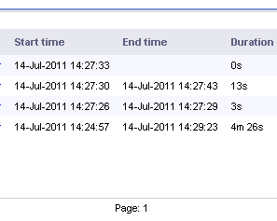
Trace Log
(11.7) 07-17-11 06:00:02 (4476:5692) JOB: Reading job <ace68f2e_faf4_40b8_842f_1a51077790ba> from the repository; Server version is <11.7.3.5>; Repository version is
<11.7.0.0000>.
(11.7) 07-17-11 06:00:02 (4476:5692) JOB: Current directory of job <ace68f2e_faf4_40b8_842f_1a51077790ba> is <E:\Program Files\Business Objects\Data Integrator 11.7\bin>.
(11.7) 07-17-11 06:00:02 (4476:5692) JOB: Starting job on job server host <UKSOBODLV03>, port <3506>. Job submitted to server group <sg_DIREPO_PROD_OTHERS>. Distribution
level <Job>.
(11.7) 07-17-11 06:00:02 (4476:5692) JOB: Job <JOB_SIS_SPECTRUMPLATINUM_REPORT_CLIENT_XML> of runid <2011071706000244765692> is initiated by user <svcBODILV02>.
(11.7) 07-17-11 06:00:02 (4476:5692) JOB: Processing job <JOB_SIS_SPECTRUMPLATINUM_REPORT_CLIENT_XML>.
(11.7) 07-17-11 06:00:03 (4476:5692) JOB: Optimizing job <JOB_SIS_SPECTRUMPLATINUM_REPORT_CLIENT_XML>.
(11.7) 07-17-11 06:00:03 (4476:5692) JOB: Job <JOB_SIS_SPECTRUMPLATINUM_REPORT_CLIENT_XML> is started.
(11.7) 07-17-11 06:00:03 (4476:5692) PRINTFN: SIS System Source Data is :4186
(11.7) 07-17-11 06:00:03 (4476:5692) PRINTFN: SQL to be submitted is: 4186
(11.7) 07-17-11 06:00:03 (4476:5692) PRINTFN: Initializing email list
(11.7) 07-17-11 06:00:03 (4476:5692) PRINTFN: Heading for Loads as the data available in the SIS System
(11.7) 07-17-11 06:00:03 (4476:5692) WORKFLOW: Work flow <WF_SIS_SPECTRUMPLATINUM_REPORT_CLIENT_XML> is started.
(11.7) 07-17-11 06:00:03 (4476:5692) PRINTFN: FILE NAME IS:\\vsukfscp01c\SIG_XML\TGT_SIG_SIS_CLIENT_20110717.xml
(11.7) 07-17-11 06:00:03 (7776:6628) DATAFLOW: Process to execute data flow <DF_SIS_SPECTRUMPLATINUM_REPORT_CLIENT_XML> is started.
(11.7) 07-17-11 06:00:03 (7776:6628) DATAFLOW: Data flow <DF_SIS_SPECTRUMPLATINUM_REPORT_CLIENT_XML> is started.
(11.7) 07-17-11 06:00:03 (7776:6628) DATAFLOW: Cache statistics for data flow <DF_SIS_SPECTRUMPLATINUM_REPORT_CLIENT_XML> are not available to be used for optimization and
need to be collected before they can be used.
(11.7) 07-17-11 06:00:03 (7776:6628) DATAFLOW: Data flow <DF_SIS_SPECTRUMPLATINUM_REPORT_CLIENT_XML> using PAGEABLE Cache with <1530 MB> buffer pool.
Monitor log
Path name | State | Row Count | Elapsed time (Sec) | Absolute time (Sec)
+DF_SIS_SPECTRUMPLATINUM_REPORT_CLIENT_XML/Q_EXTRACT | PROCEED | 4000 | 0.156 | 2.254
/DF_SIS_SPECTRUMPLATINUM_REPORT_CLIENT_XML/CacheSplit | PROCEED | 4000 | 0.156 | 2.254
/DF_SIS_SPECTRUMPLATINUM_REPORT_CLIENT_XML/CacheSplitMemoryReader | PROCEED | 1000 | 9.906 | 12.176
/DF_SIS_SPECTRUMPLATINUM_REPORT_CLIENT_XML/CacheSplitMemoryReader[1] | PROCEED | 1417000 | 11.375 | 13.645
/DF_SIS_SPECTRUMPLATINUM_REPORT_CLIENT_XML/Q_EXTRACT0 | PROCEED | 1416000 | 11.375 | 13.645
/DF_SIS_SPECTRUMPLATINUM_REPORT_CLIENT_XML/Q_GENERATE_XML-Nest1: 0 | PROCEED | 0 | 0.000 | 2.270
/DF_SIS_SPECTRUMPLATINUM_REPORT_CLIENT_XML/Q_GENERATE_XML-Nest1: 1 | PROCEED | 1415000 | 11.359 | 13.629
/DF_SIS_SPECTRUMPLATINUM_REPORT_CLIENT_XML/Q_GENERATE_XML | PROCEED | 0 | 0.000 | 5.317
-DF_SIS_SPECTRUMPLATINUM_REPORT_CLIENT_XML/GUID::'898fc205-6ea6-4058-9d4a-5253be8c56a7' LOAD MESSAGE "$File | PROCEED | 0 | 0.000 | 5.317

Error log-
(11.7) 07-17-11 06:00:15 (E) (7776:6224) RUN-050505: |Dataflow DF_SIS_SPECTRUMPLATINUM_REPORT_CLIENT_XML|Transform Q_GENERATE_XML-Nest1
Unknown error in transform <Q_GENERATE_XML-Nest1>.

DMP Files:
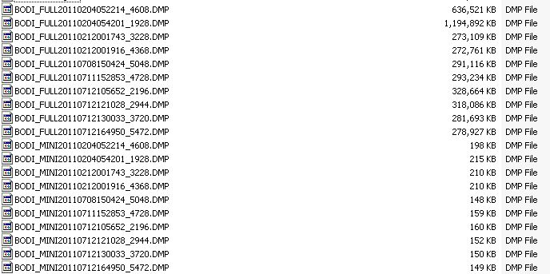
Monitor Log for properly completed job with source 936 records
See 936*936=876096
Path name | State | Row Count | Elapsed time (Sec) | Absolute time (Sec)
+DF_SLAC_AAPSPCE_CLIENT_XML/AAPSPCE1 | STOP | 936 | 0.000 | 298.072
/DF_SLAC_AAPSPCE_CLIENT_XML/Q_EXTRACT | STOP | 936 | 0.000 | 298.072
/DF_SLAC_AAPSPCE_CLIENT_XML/CacheSplit | STOP | 936 | 0.000 | 298.072
/DF_SLAC_AAPSPCE_CLIENT_XML/CacheSplitMemoryReader | STOP | 936 | 2.266 | 298.072
/DF_SLAC_AAPSPCE_CLIENT_XML/CacheSplitMemoryReader[1] | STOP | 876096 | 7.391 | 298.072
/DF_SLAC_AAPSPCE_CLIENT_XML/Q_EXTRACT0 | STOP | 876096 | 7.391 | 298.072
/DF_SLAC_AAPSPCE_CLIENT_XML/Q_GENERATE_XML-Nest2: 0 | STOP | 936 | 7.391 | 298.072
/DF_SLAC_AAPSPCE_CLIENT_XML/Q_GENERATE_XML-Nest2: 1 | STOP | 876096 | 7.391 | 298.072
/DF_SLAC_AAPSPCE_CLIENT_XML/Q_GENERATE_XML | STOP | 936 | 93.908 | 298.072
-DF_SLAC_AAPSPCE_CLIENT_XML/GUID::'a944cb3e-fc49-4b29-b711-85614baf96fd' LOAD MESSAGE "$File | STOP | 936 | 294.240 | 298.072

