Problem:
Note: Case XXXXX was opened to SAP for this issue.

When working with the PERSON_FIRM_EN data cleanse transform in Designer, the output tab should be populated. We had issues with this tab being empty.

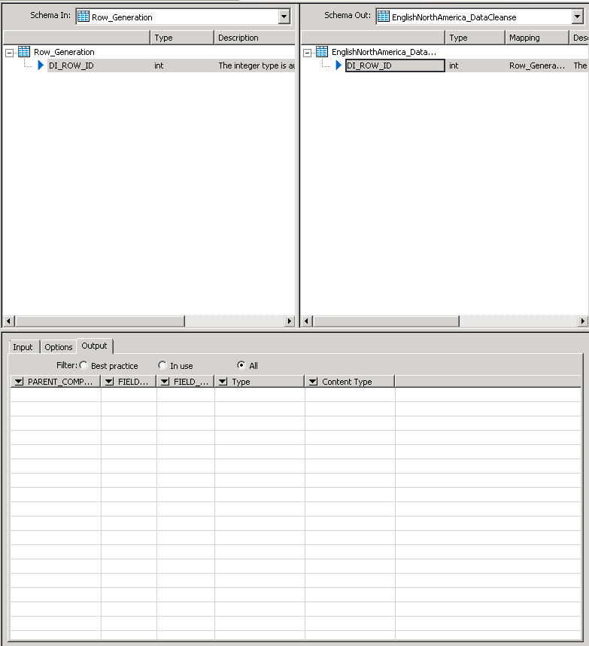

Resolution:

To fix the issue:
- Search the input file repository for “72161*”.
- Copy the 72161_LE_VER*.db file from the input file repository to the LINK_DIR\DataQuality\datacleanse\<jobservername?> on the machine where Designer is installed.
- Rename the file in the destination directory by removing the guid info. The filename will now be 72161_LE_VER.db.
- Copy the 72161_LE_PER*.db file from the input file repository to F:\appdatasvc01d_6400. This is a cache directory we set up on the job server. Normally it would have been C:\SAP\SAP BusinessObjects\Data Services\log\pCache\<local repo port>.
- Rename the file in the destination directory by removing the guid info. The filename will now be 72161_LE_PER.db.
- After doing so, the output tab should now be populated.
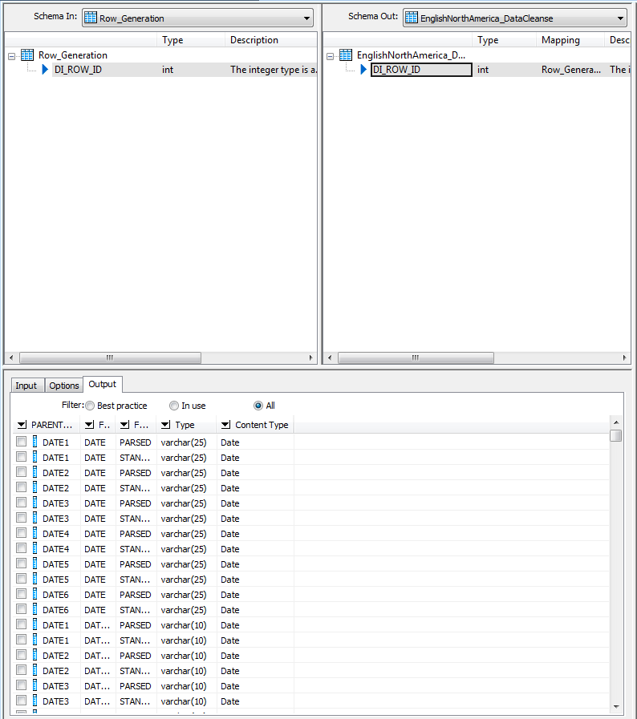
- If the output tab shows only EXTRA1 thru EXTRA12:

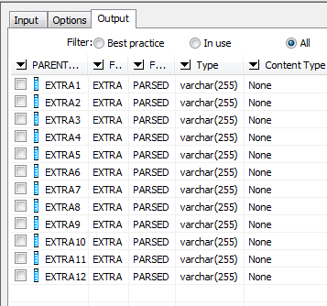

Go to the Options tab, scroll all the way to the bottom and change the Filter Output Fields option from SHOW_RELEVANT_FIELDS to SHOW_ALL_FIELDS.

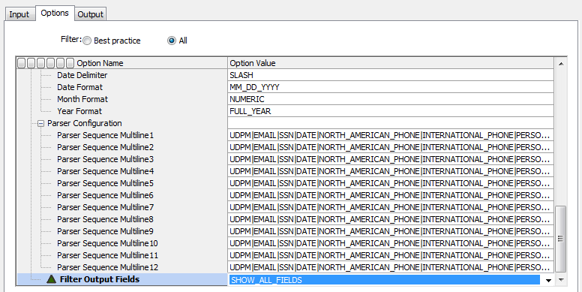
Save the dataflow or the change will revert back to SHOW_RELEVANT_FIELDS. The output tab will now be fully populated.
