Sending scheduling objects to a secure FTP Location

Nature of Requirement: The main object of this document is transferring the files from Windows to Unix server on scheduled basis.

Development Process:

- Create the batch and Script file

- Configuring the job servers

- Upload the batch file into the BO CMC.

- Create a event in CMC

- Schedule the Report at specific time with event.

Pre requisites: ➔ Winscp3 S/W should be there on Bo server

➔ Verify whether the FTP user is able to send the files from windows to FTP
Location by putty or Winscp3.

➔ Check the FTP user rights

STEP 1: Create the batch and Script file

➔ Batch file

Copy the below code into txt and save the file with an extension of .bat on Bo server

D:
Cd D:\winscp3
Winscp3.com sftp://FTPUSERNAME: PASSWORD@IP /script=Scriptfilename.txt
Exit
Exit

Here is the breakdown of the commands in the file.

D:\Winscp3 ➔ Location of the winscp3 exe file

FTPUSERNAME ➔ FTP username

PASSWORD ➔ Password

IP ➔ IP Address

Scriptfilename.txt ➔ File name of the script file

Example: ftp_program.bat

D:
Cd D:\winscp3
Winscp3.com sftp://ftpuser:****@3.194.11.22/script=script.txt
Exit
Exit

➔ Script file

Copy the below code into txt and the file with an extension of .txt on where winscp3 .exe file location.

Option batch on
Option confirm off
Option transfer binary
Pwd
Put Drive name:\location of the foldername\reportname

Close
Exit

Here is the breakdown of the commands in the file.

Drivename: location of the drive where the report needs to be locates in BO server

Location of the foldername: If you have any foldername needs to be mentioned here

Report name: Name of the Report.

Example: Script.txt

Option batch on
Option confirm off
Option transfer binary
Pwd
Put D:\BO_FTP_REPORTS\reportname
Close
exit

STEP 2: Configuring the crystal report job servers

BO CMC ➔ Servers ➔ selected job server properties

Needs to be update the destination directory with the drive and folder name

Configure the same for other job servers (Desk I, Destination, Web I)

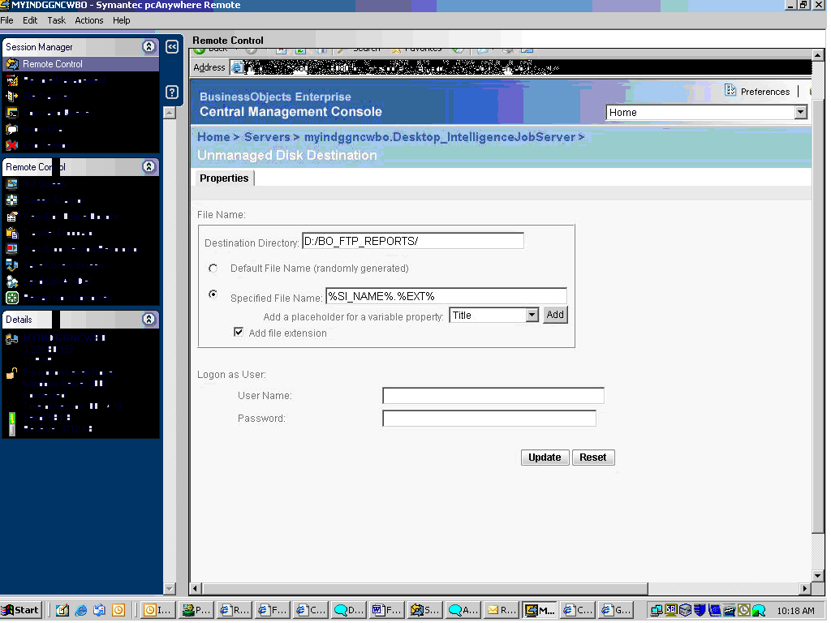

STEP 3: Update the Batch file

Bo CMC ➔ New Object ➔ Click on Program pls refer the next two slides

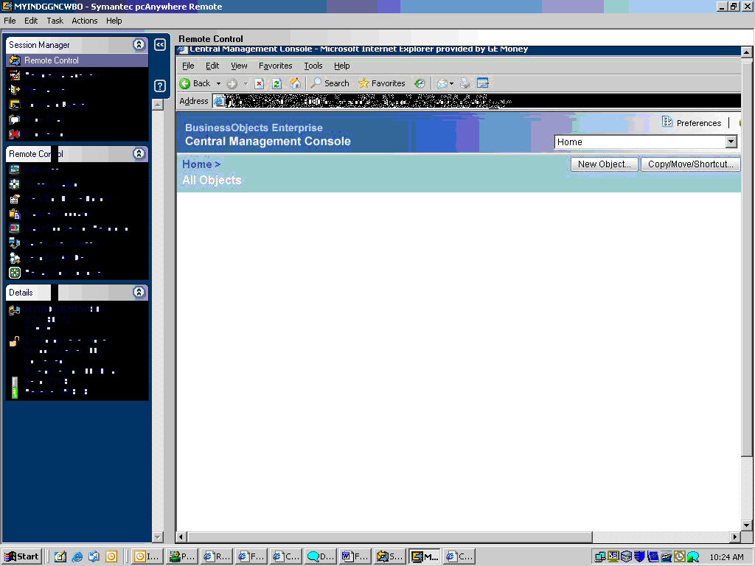

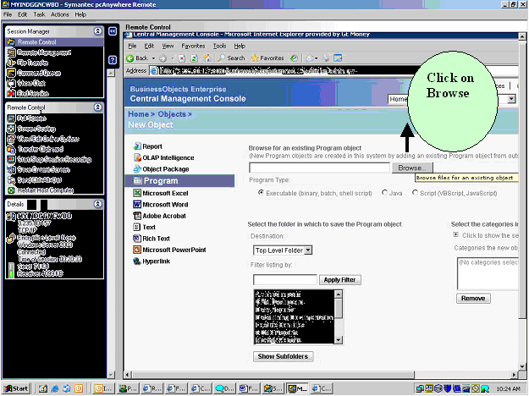

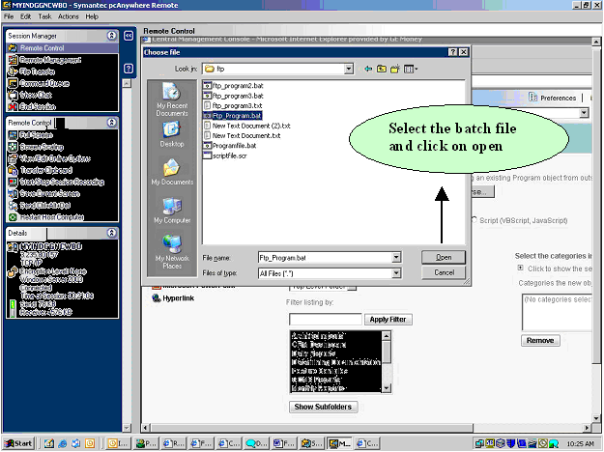

STEP 4: Create a event in BO CMC

Bo CMC ➔ Event ➔ Enter the name of the event name pls refer the screen shot

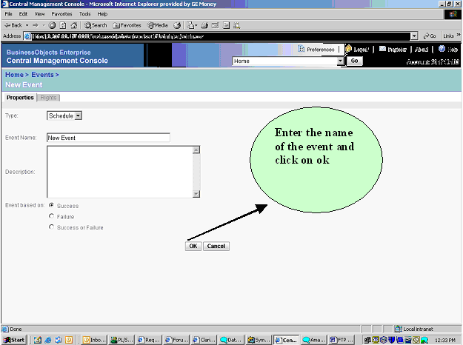

STEP 5: Schedule the Report and Event at specific time with event.

Report Specific Time:

Pls refer the screen shot and event at available schedule events and click on Add to Events to trigger on completion (on success)

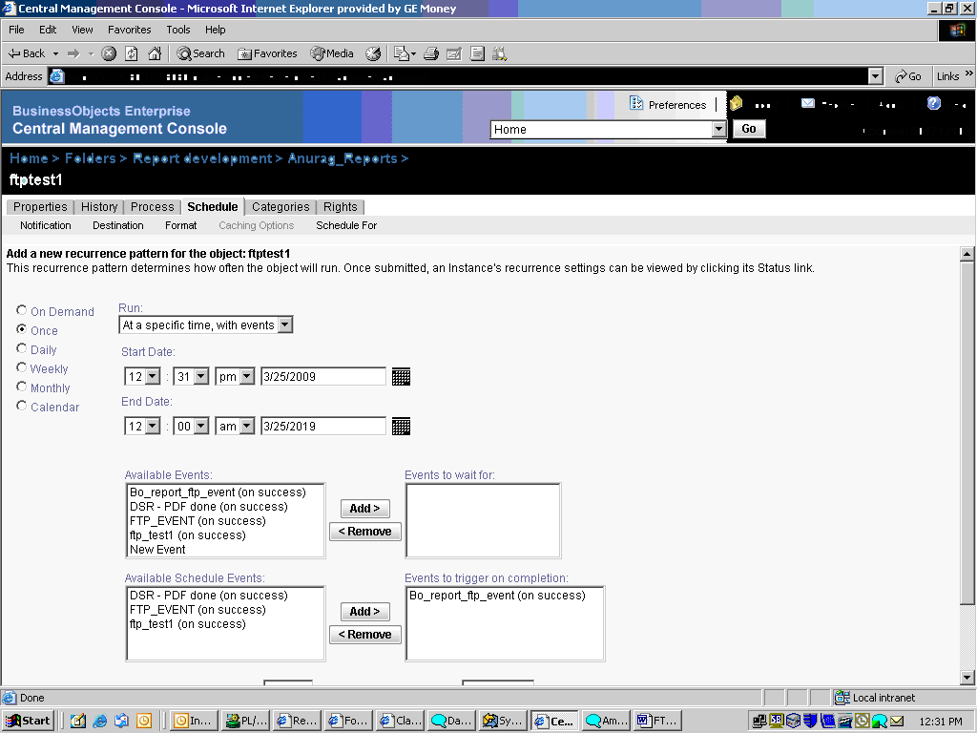

Event Specific Time: Pls refer the screen shot

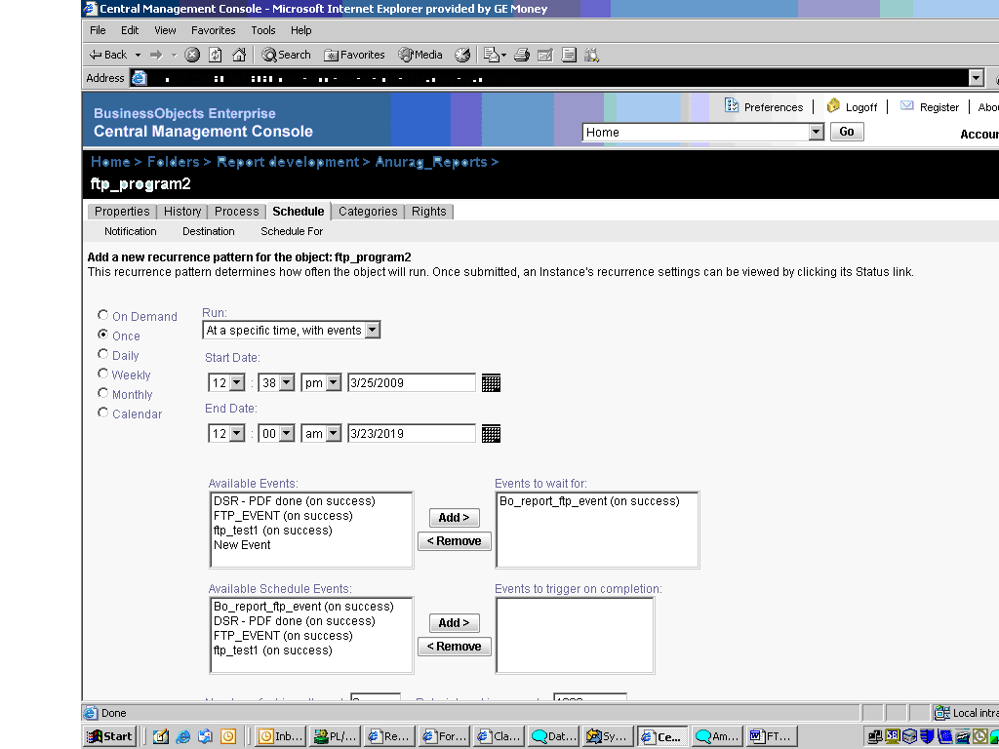

Constraints:

➔ For each and every report we have to create one batch, script file and event.

