From Crystal thick client report results are coming up below.

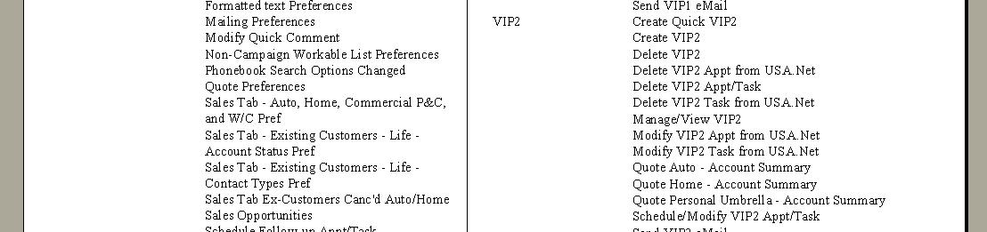

Where as, in Infoview report results are displaying with additional space.

