When Advanced DHTML Viewer was used (This error always comes after 10 minutes):
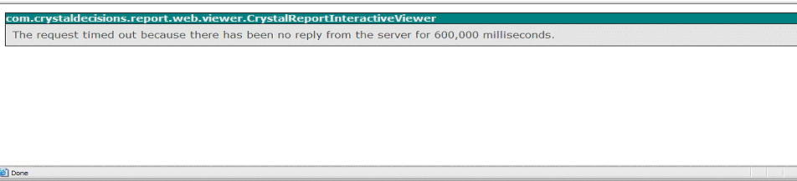

When Activex Viewer was used (after 40 mins):
