The publication is now pointing to the base Dynamic Recipient Webi Report.
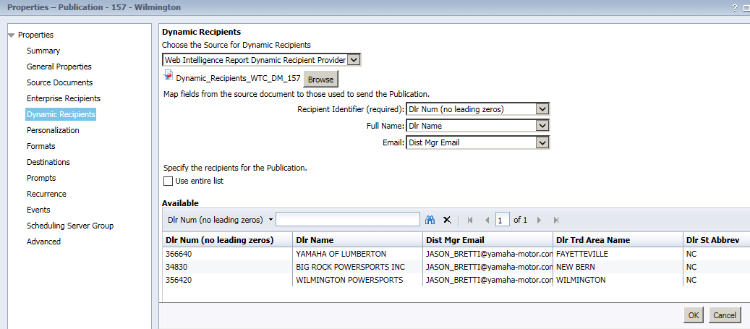

I schedule the Dynamic Recipient nightly. This is the report I want to use as the Dynamic Recipient, but don't see it from the publication.
