This is the parameter page. I have only one parameter in my report.
When I ‘Preview’ it, I get this page and I enter the date and time value.

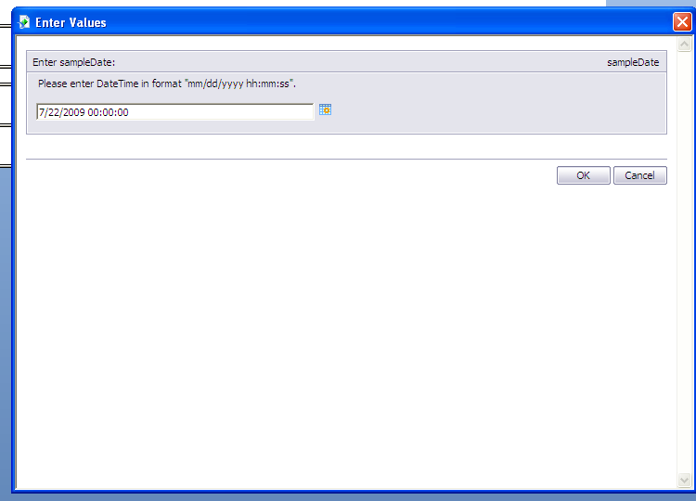

This is how I get it in the “preview’.
The time value of 00:00:00 is taken as 12:00:00AM

