Daily Batch File

Issue
BusinessObjects writes information, via the CMS, to TORODHW1 database. Each Saturday the database or server is bounced at 11:05 PM. The CMS tries to connect to the TORODHW1 several times, and then turns off. Unless manual intervention occurs, the users will not be able to login on Monday.

Resolution
A batch file, CMS.bat, will start the server daily at 4 AM. This will ensure that the CMS is always up and that DBA’s won’t be required to perform manual intervention. The bat file can be found in D:\BATCH on report server TOROEPLANDEV01.

The code is very simple:
:: CMS.bat
:: restarts BusinessObjects CMS every day
::
@ECHO OFF

net start BOBJCentralMS

The double colons are for comments. The @ECHO OFF ensures that the file runs in the background. The net start BOBJCentralMS is the command that forces the CMS to restart.
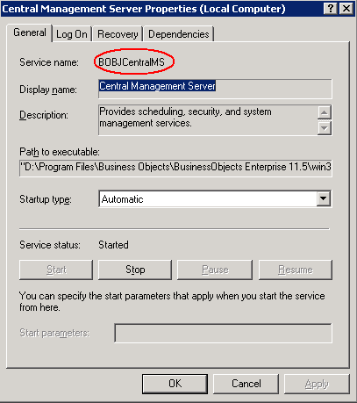
Why is the CMS referred to as BOBJCentralMS? This is the name found in the Microsoft Services Program.

Via the scheduler on toroeplandev01, I then scheduled this batch file to be run every morning at 4 AM. The windows scheduler can be found by selecting the Start menu, Program files, Accessories, System tools.

As a test I scheduled the batch file to run at 6:07 PM.
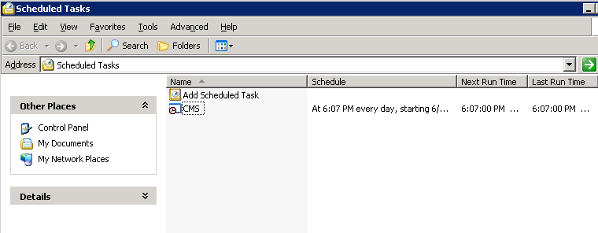

I then stopped the CMS. At 6:07 PM, the DOS window notified me that the batch file had been executed.

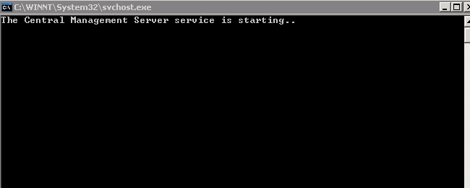

CMS began to run:
