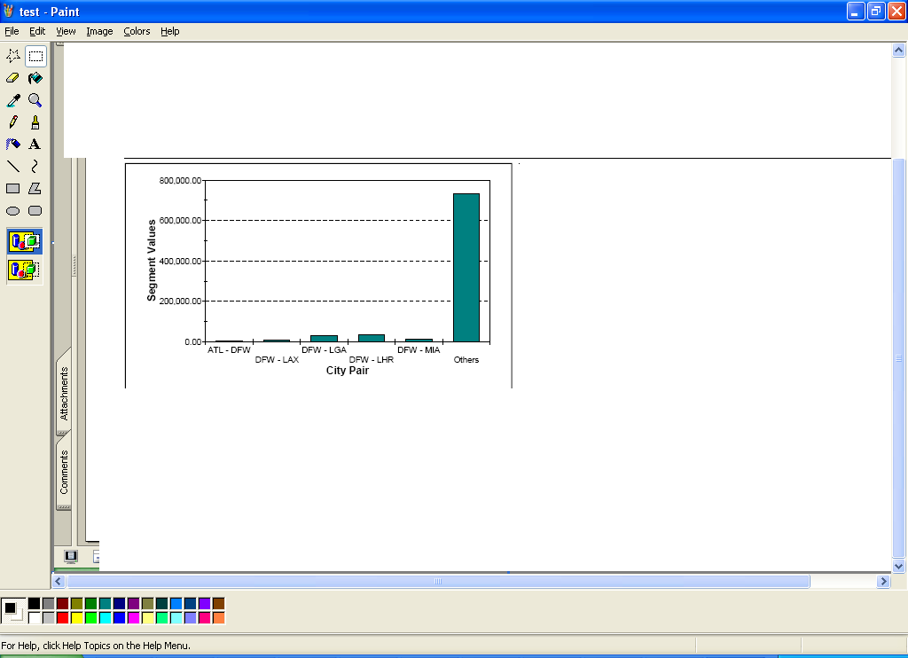
Here I want to show others also , I city pair and segment value and I found others also but I don’t know how to show in graph could please help me.

