Issue description: Data flow using Table Comparison method as sorted input is hanging for forever.

Issue detail:
Data flow which has table comparison transformation with sorted input, is issuing the query to sort the data from TC irrespective to source has no records to process. This process, ‘Source transformation has zero records to process but TC has issued query to DB to sort the record to compare’ is running infinitely.

Following 4 pics shown the stating the process, data flow, monitor log, Data base query and status.
Why TC transformation is issuing the query if no records in source transformation and why is it not ending the process?

Picture 1:
Data flow where BODS bug has encountered.

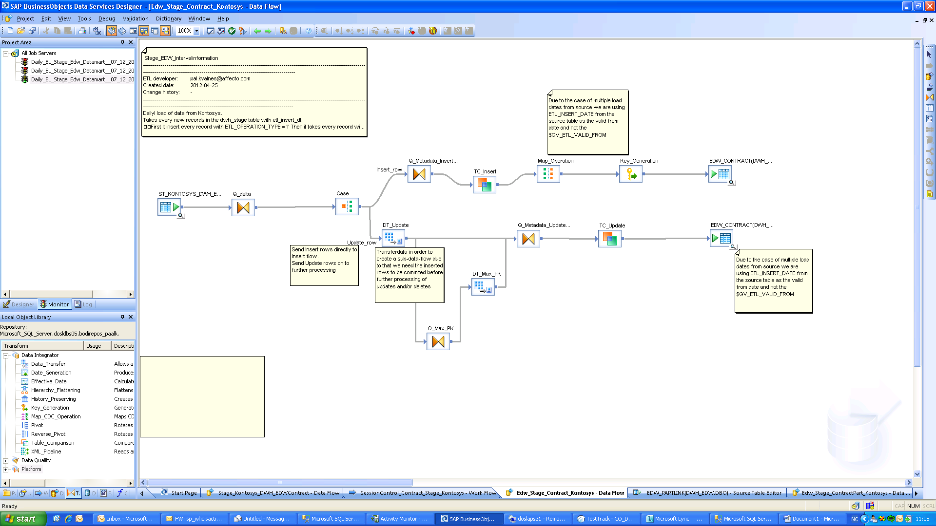

Picture 2:

Monitor log showing no records to process.
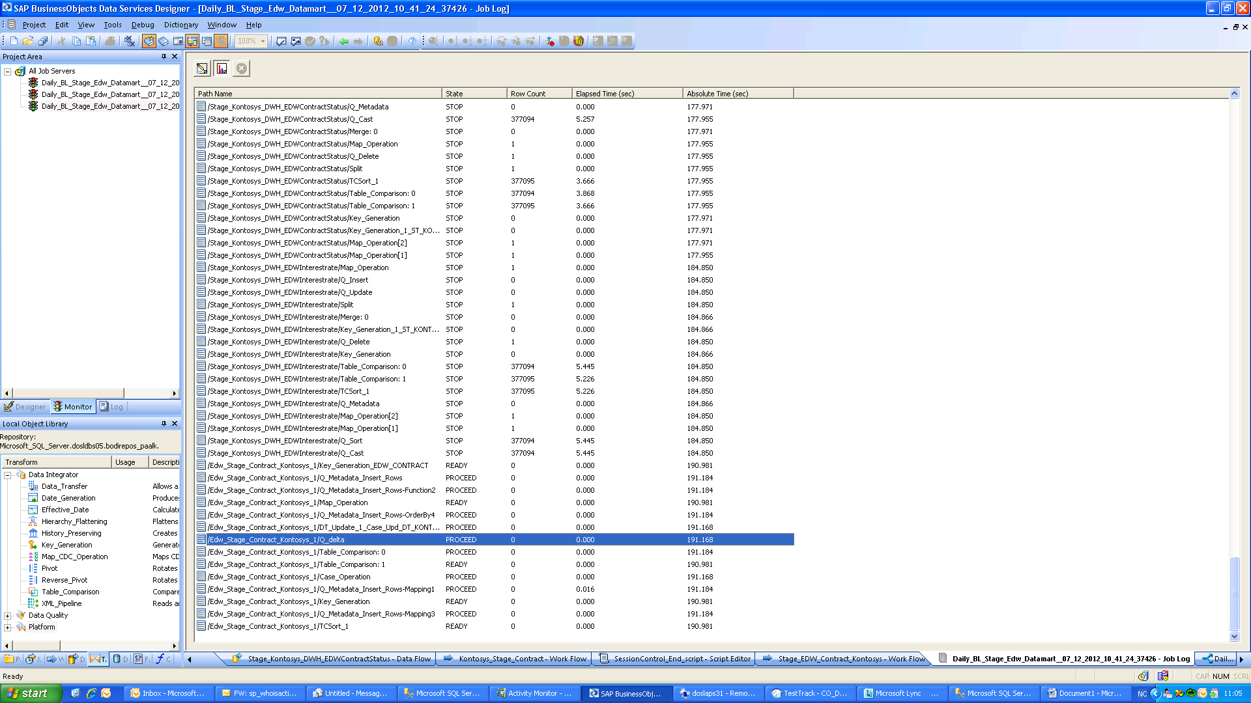

Picture 3:

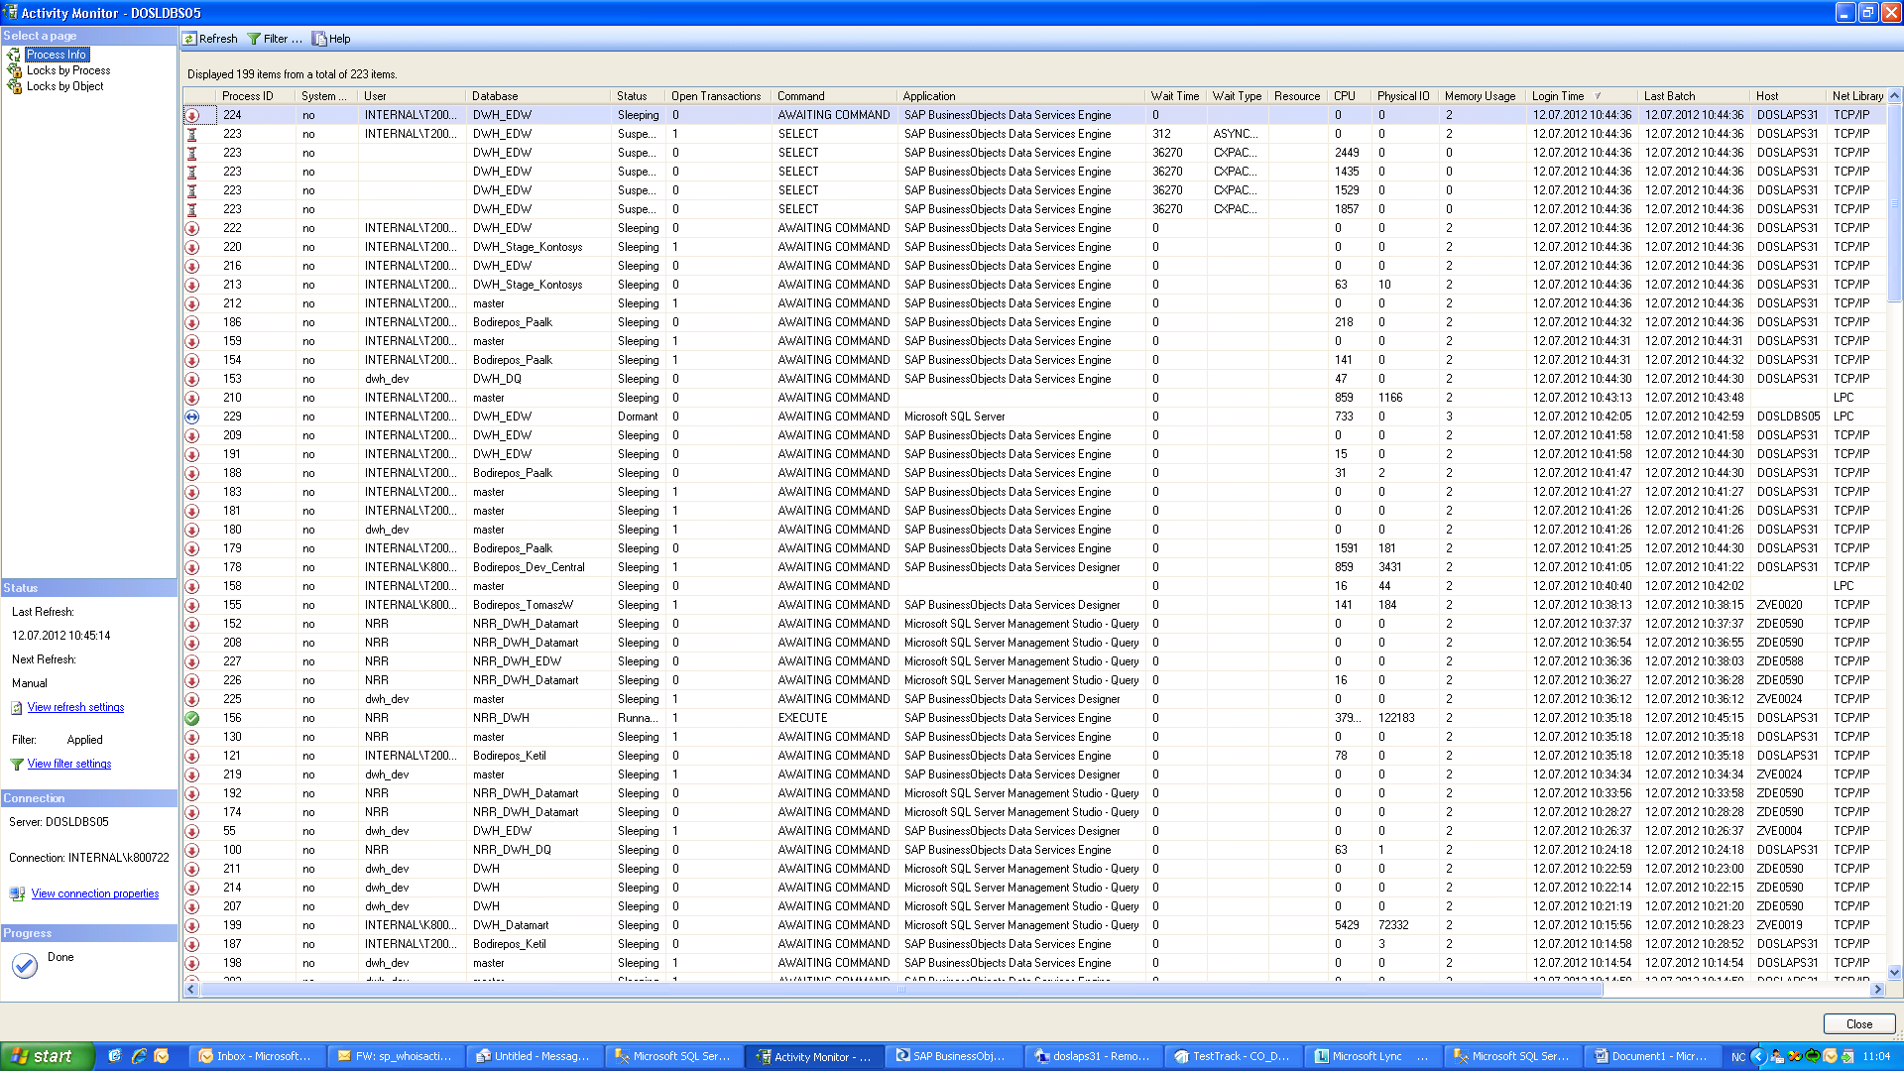

Query issued by TC

<?query --
SELECT "TCRdr_1"."PK_EDW_CONTRACT" ,
"TCRdr_1"."CONTRACTBUSINESSID" ,
"TCRdr_1"."CONTRACTSTARTDT" , "TCRdr_1"."CONTRACTENDDT" ,
"TCRdr_1"."CONTRACTENDINITIALDT" , "TCRdr_1"."CONTRACTFIRSTINVOICEDT" ,
"TCRdr_1"."CONTRACTCHANNEL" , "TCRdr_1"."PAYOUTAMT" , "TCRdr_1"."PAYOUTCURRENCY" ,
"TCRdr_1"."CONTRACTVALUE" , "TCRdr_1"."CONTRACTVALUEINITIAL" , "TCRdr_1"."INTERESTRATEINITIAL" ,
"TCRdr_1"."INTERESTMARGININITIAL" , "TCRdr_1"."LIMITINITIAL" , "TCRdr_1"."FIXEDINTERESTFLG" ,
"TCRdr_1"."INSTALMENTINITIAL" , "TCRdr_1"."OWNFUNDING" , "TCRdr_1"."RESIDUALVALUE" , "TCRdr_1"."CURRENCY" ,
"TCRdr_1"."APPROVALDT" , "TCRdr_1"."CREATIONDT" , "TCRdr_1"."FK_EDW_MST_SOURCESYSTEM" , "TCRdr_1"."FK_EDW_MST_COUNTRY" ,
"TCRdr_1"."FK_EDW_APPLICATION" , "TCRdr_1"."FK_EDW_MST_PRODUCT" , "TCRdr_1"."FK_EDW_CAMPAIGN" , "TCRdr_1"."FK_EDW_INTERMEDIATE" ,
"TCRdr_1"."FK_EDW_INTERMEDIATESALESMAN" , "TCRdr_1"."FK_EDW_SUPPLIER" , "TCRdr_1"."FK_EDW_SUPPLIERSALESMAN" , "TCRdr_1"."FK_EDW_SALESMAN" ,
"TCRdr_1"."FK_EDW_AGREEMENT" , "TCRdr_1"."FK_EDW_MST_PAYMENTTYPE" , "TCRdr_1"."FK_EDW_CONTRACTTOPUP" , "TCRdr_1"."SOURCETABLE" ,
"TCRdr_1"."SOURCEKEYCOLUMN" , "TCRdr_1"."SOURCEKEY" , "TCRdr_1"."ETL_FROM_DT" , "TCRdr_1"."ETL_TO_DT" , "TCRdr_1"."ETL_ACTIVE_FLG" ,
"TCRdr_1"."ETL_INSERT_DT" , "TCRdr_1"."ETL_MOD_BY"
FROM "DBO"."EDW_CONTRACT" "TCRdr_1" ORDER BY "TCRdr_1"."FK_EDW_MST_SOURCESYSTEM" ASC ,
"TCRdr_1"."CONTRACTBUSINESSID" COLLATE Latin1_General_BIN ASC , "TCRdr_1"."PK_EDW_CONTRACT" DESC
--?>

