AFTER DOING REPAIR ALL SERVICES ARE SHOWN DISABLED.
Dated: 07/01/2012

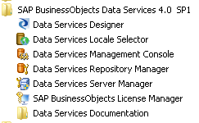

When we launched the DS services the following error messages are obtained.

Data Service Designer

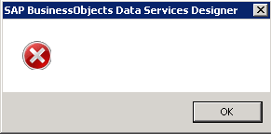

Data Services Server Manager

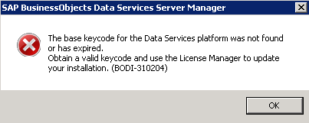

SAP Business Objects License Manager

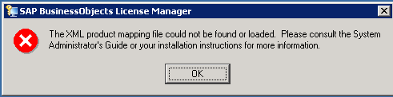

ACCESS SERVER

Access Server ‘dcadpd701:4000’ is not available. If SSL protocol is used, the java keystore for the management console must contain the certificates for the access server. (BODI- 3016130)
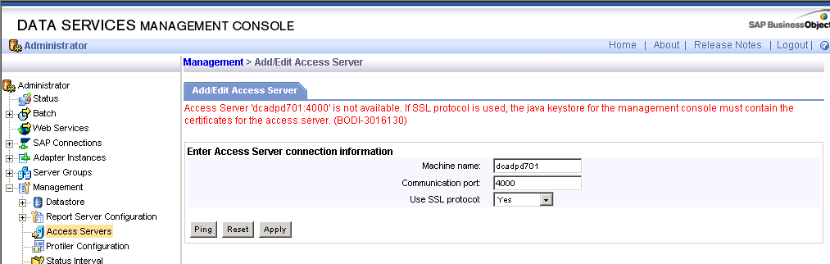

JOB SERVER
Job server DCADPD701:3500 is not accessible. Connection refused:connect
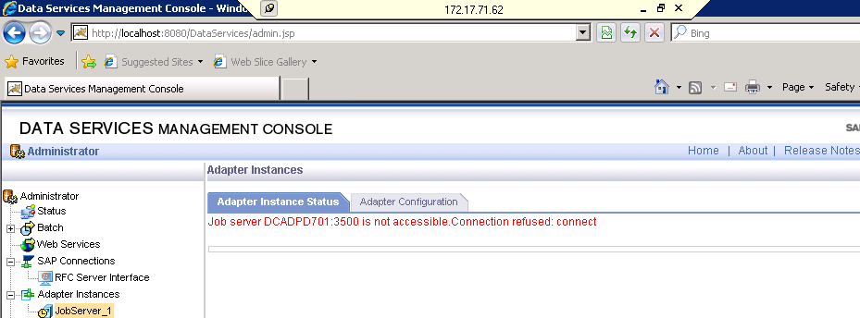

Findings:

Option1: Find the side-effects happened after doing REPAIR

>> Server manager, license manager and designer have failed to start
>> Access server & Job server are not reachable on their respective ports
Job server adapter error
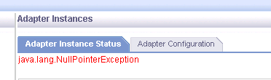. 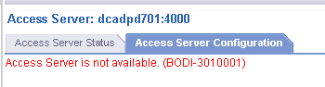

>> Connection to CMS is successful

Option3: An only Data service is affected and CMS is perfectly fine.

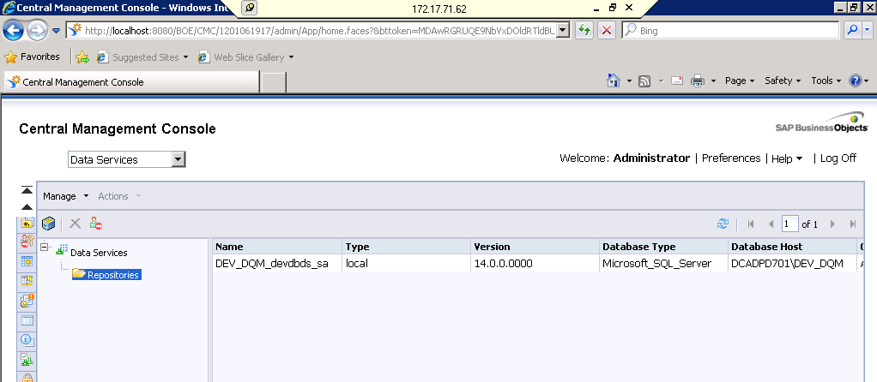

>>> License Check in reg edit

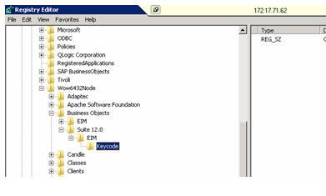

Click on modify

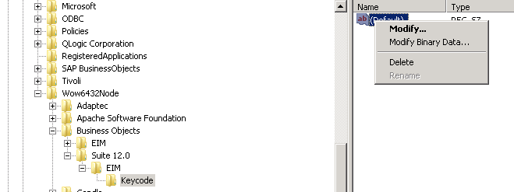

Entered the permanent license

DONE SYSTEM RESTART

LAUCHED DS SERVER MANAGER ---- “NO CHANGES FOUND “

