Exploration View Set
This View set below is based on the "ROi Inventory Infospace" and "ROi Datamart Infospace"
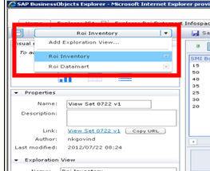
ROi Inventory Infospace: This infospace is used for analysis between "Slow Move Inventory On Hand Quantity" vs "Slow Move Inventory Dollars".
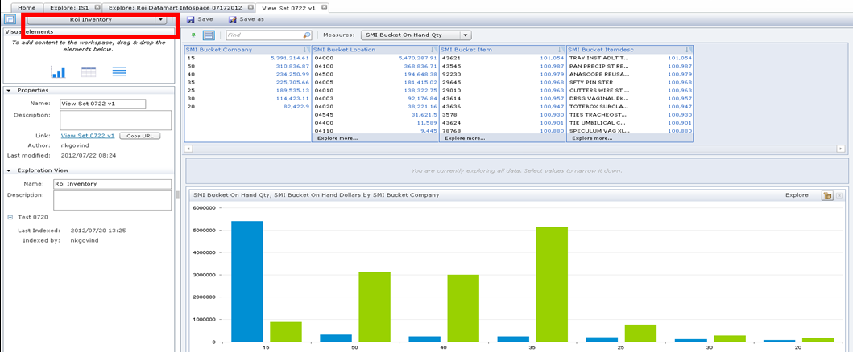
ROi Datamart Infospace: This infospace is used for analysis between "# of Supplies Used" vs " Cost of supplies used" .
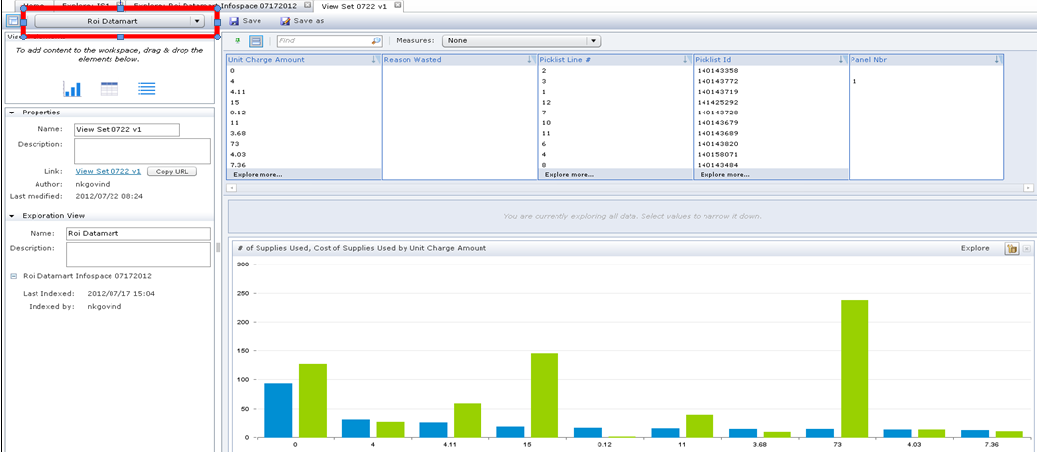
What I need is both this charts to be displayed in a single page, not to switch between them separately.

