When I login to Universe Designer with IP address I have different error message. And when I login with machine name it’s a different error message.

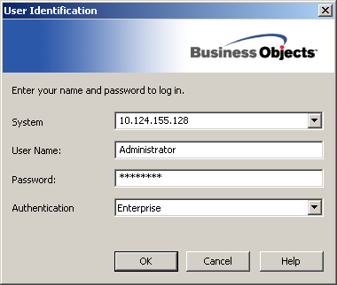

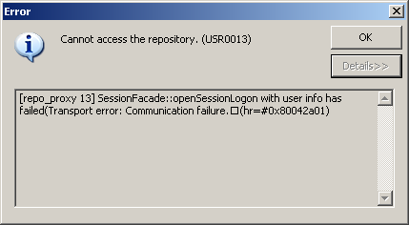

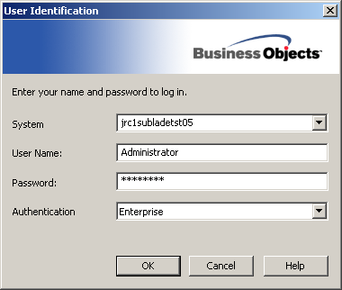

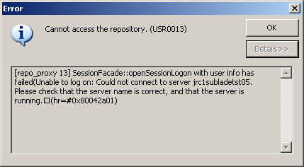

When I login to the Deski with below credentials I could login to the deski without any problems.
I applied same System name 10.124.155.128:9080 (J2EE Portal) in universe designer but no luck.
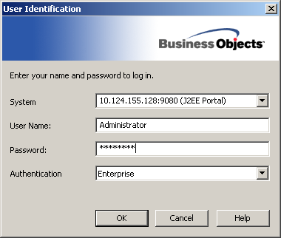

Note: I cannot ping to the CMS server as Ping is disabled.

