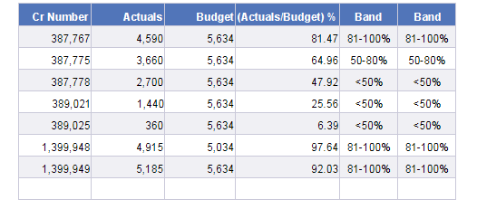

First Band
[Band] =If ([Calc in %] < 50) Then "<50%" ElseIf ([Calc in %] >= 50 And [Calc in %] <= 80) Then "50-80%" ElseIf ([Calc in %] >= 81 And [Calc in %] <= 100) Then "81-100%" ElseIf ([Calc in %] > 100) Then ">100%"

Second Band
[ Band] =[Band] ForEach([Cr Number])

With the help of second band im creating Drill Filter (Dragging “Second Band” into drill/Analysis section”

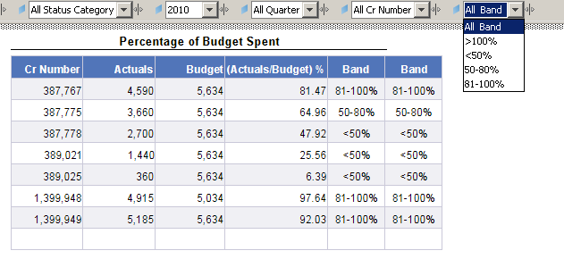

Now as im selecting any of the option available in the drill filter, im getting Zero output
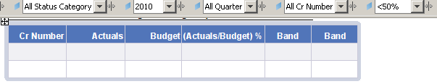

If I select “All Band”; its giving me original table

When I tried to Drag the second Band [ Band] on to report, im getting
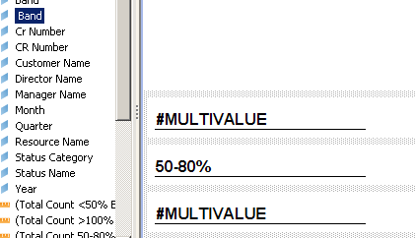

Not sure How to implement;
If I select the option from Drill filter, it should give me right filtered option.

