Apache Tomcat 5.0.27 in CCM

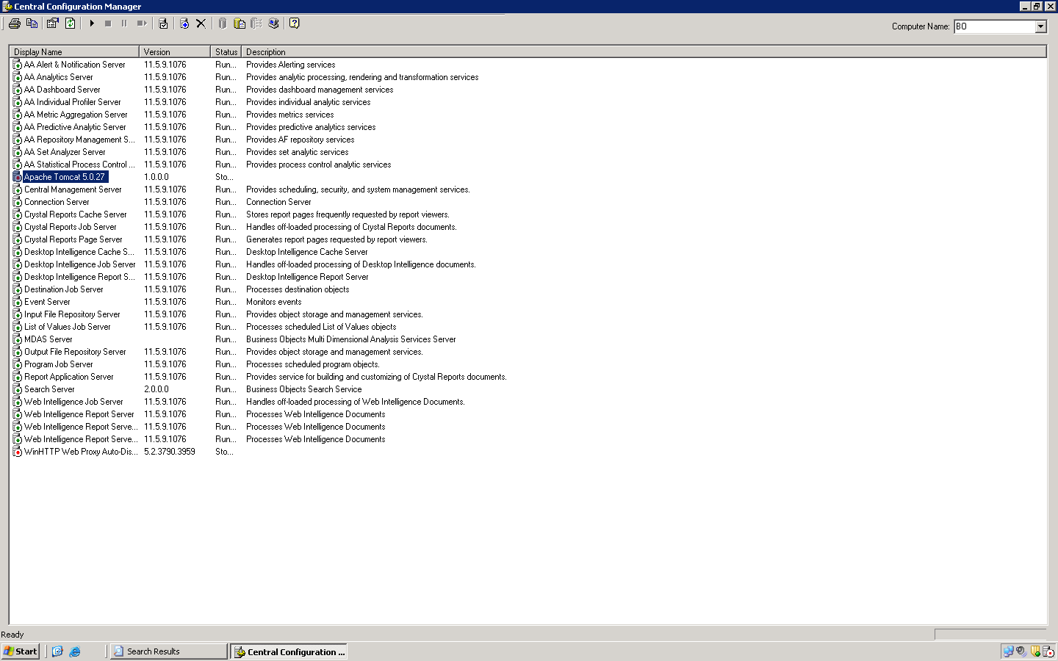

Command line in CCM shows, it refers tomcat5.exe
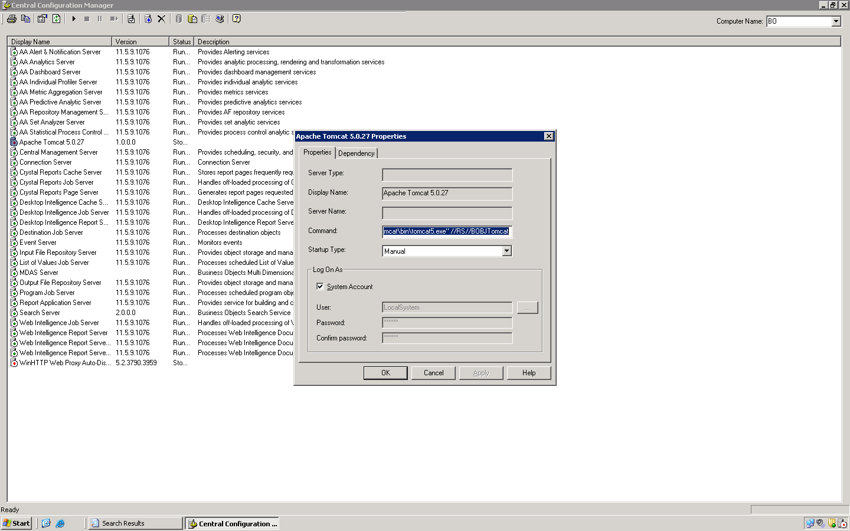

Apache Tomcat 5.0.27 Configuration

