A universe X was created in designer (using administrator status). A group was then created in CMC (group_X) and users ( user_X) were added to this group.
The group has Advanced access to the secure connection attached to this universe, Advanced access to universe X as well as Advanced access to desk top intelligence (Business Objects Enterprise Applications).

However, after logging onto Desktop Intelligence as user_X,

The following screens were returned:

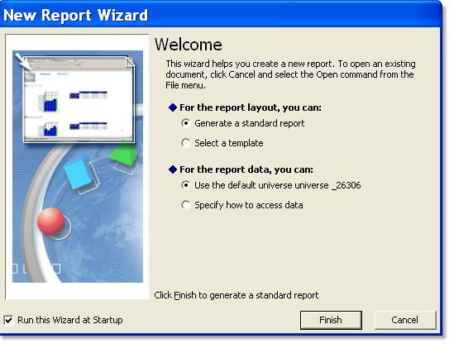

Where universe_26306 is universe_X.
Followed by :
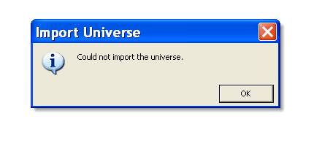 And

